17MDC6 – DIGITAL MARKETING LABORATORY

PROJECT REPORT

#### SS CAKES

TEAM MEMBERS:

2033030 – SANTHOSH KV

# INTRODUCTION:

**SS CAKES** is an Indian cakes and sweat startup company and Founded in 2022. It is not only for cakes abut also for sweat items like Laddu, etc...

SS CAKES provides offers delicious cakes with many variety

* *chocolate*
* *butterscotch*
* *strawberry*
* *pine apple, etc..*

The uniqueness of the store is the core, which delivers "delicious at low cost".

SS shop is designed to offer a unique shopping experience for the entire family through wide aisles, coordinated displays and highly trained professional chefs offering best in class customer assistance. customer through visiting SS CAKES Official Website can access a large collection of delicious, many variety of cakes and products at great value delivered at their door steps.

# PROCEDURE:

**STEP 1:**Create a calendar and add tasks for the future and mark it as completed once done.

**STEP 2:** Create an official mail ID for the business, and with that create various social media accounts for promotions.

**STEP 3:** Create a website for your business and connect it to google analytics for better results and insights.

**STEP 4:** After creating a website, add keywords to it to make your website reach more people.

**STEP 5**: Create posters, reels and videos about your business and post it in your respective social media platforms.

**STEP 6:**Share the content with your family and friends and then promote your content in social media.

**STEP 7:** After few days, check with the results and analyse the reach of your content.

# Digital marketing channels:

YOUTUBE: 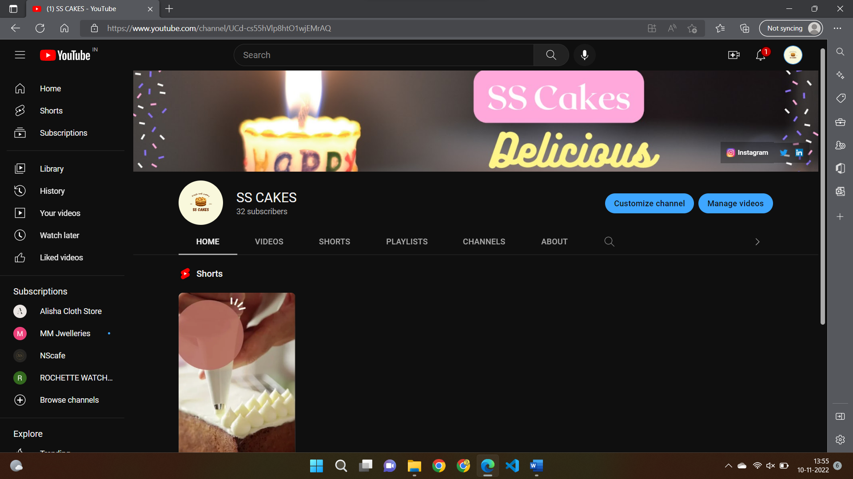

INSTAGRAM:

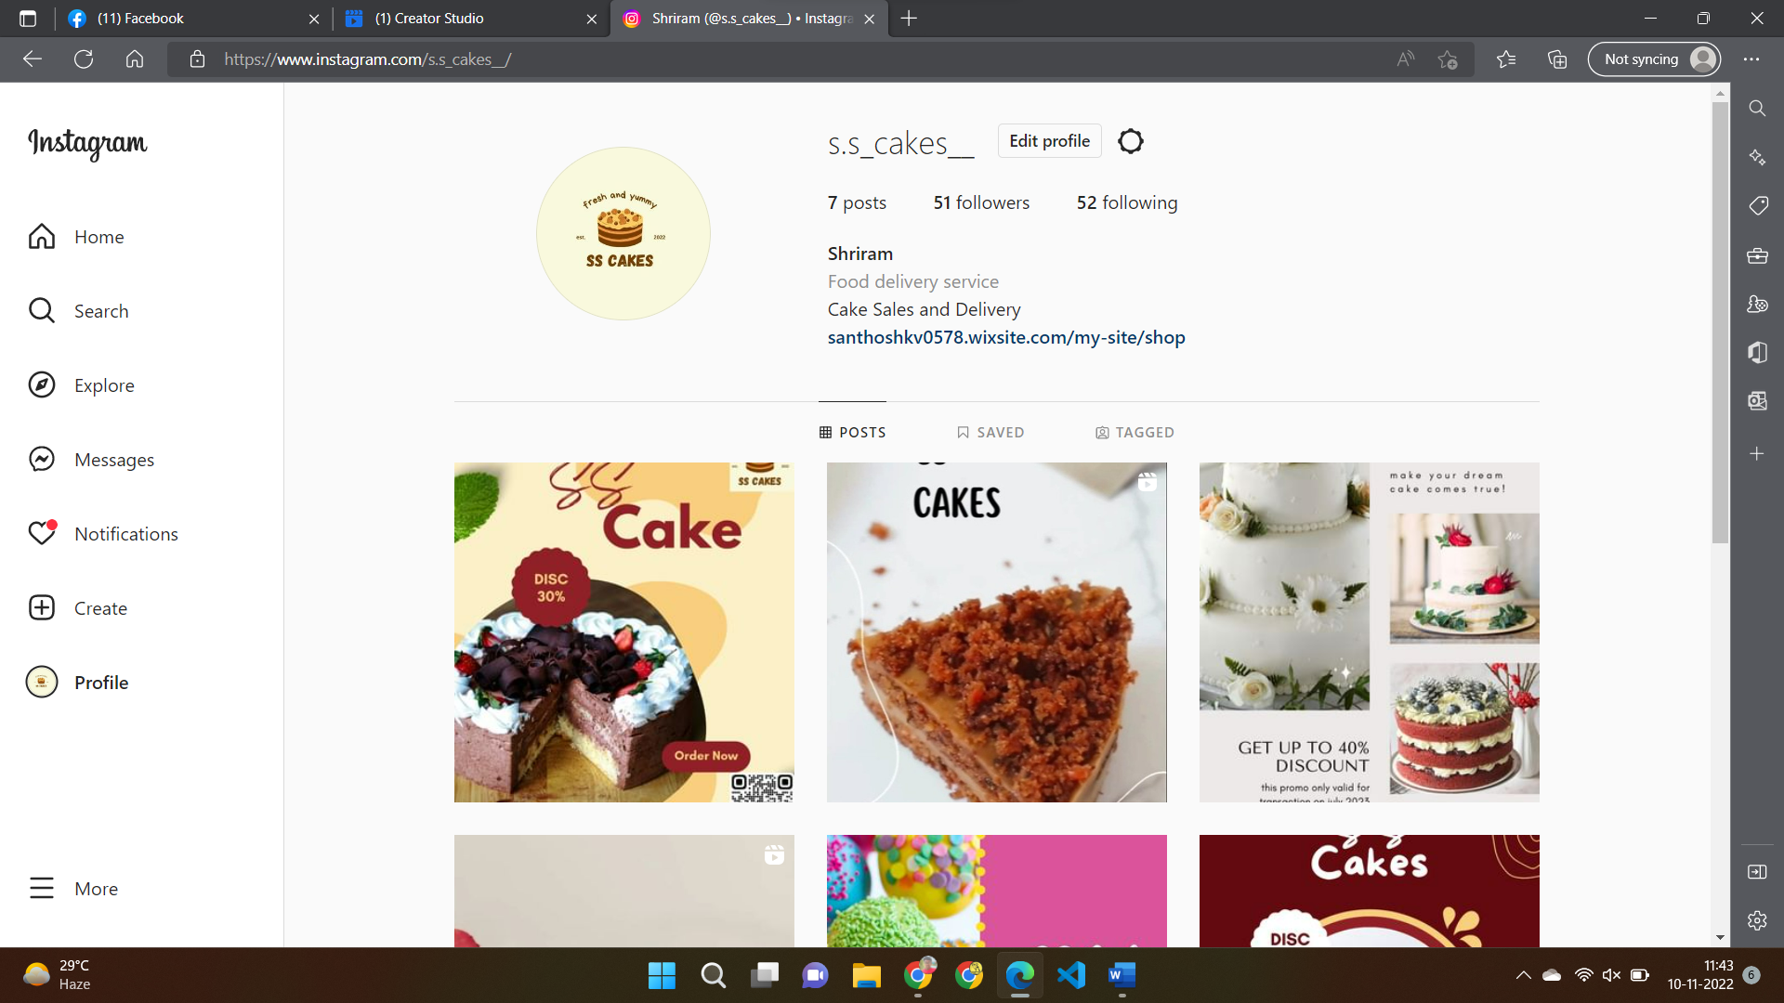

FACEBOOK:

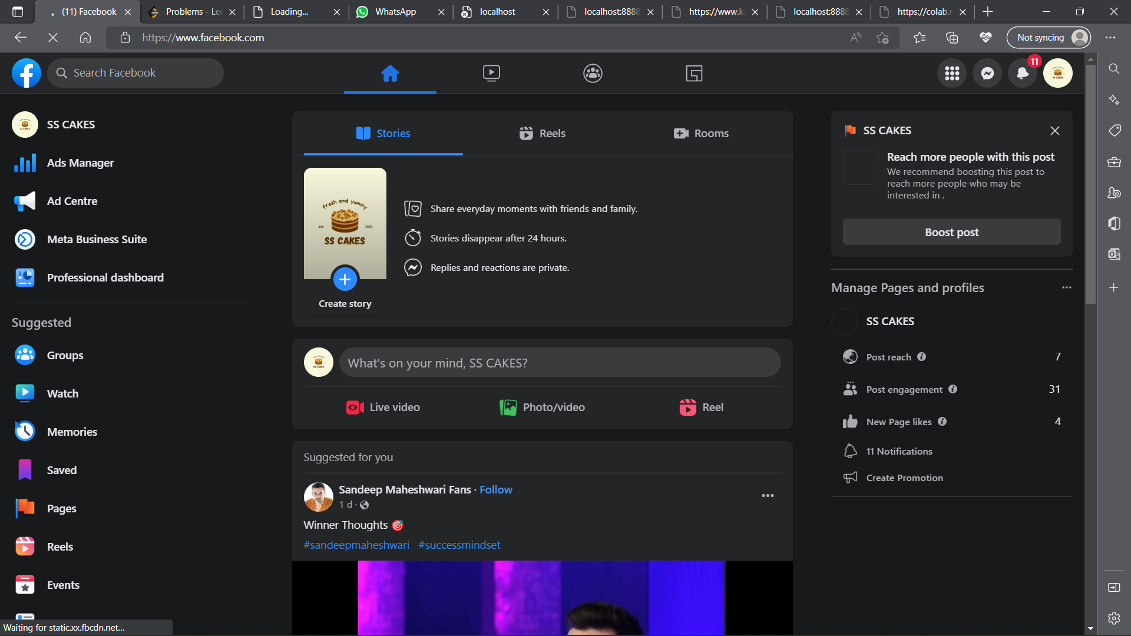

TWITTER:

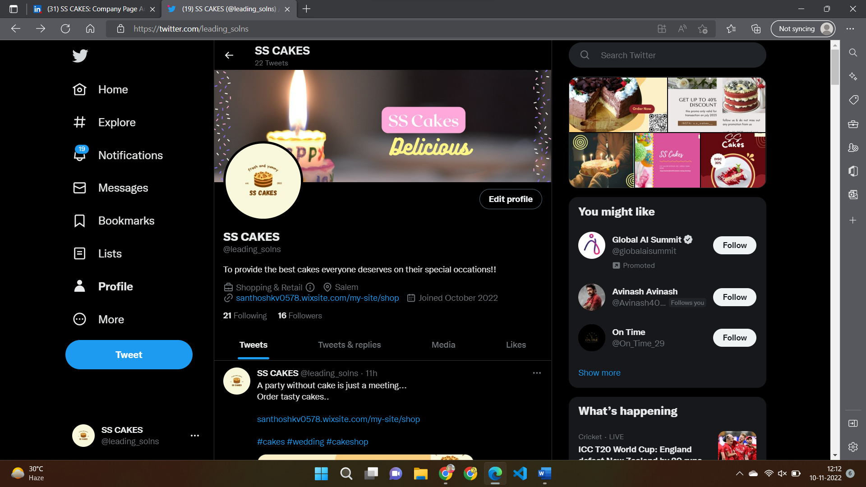

LINKEDIN: 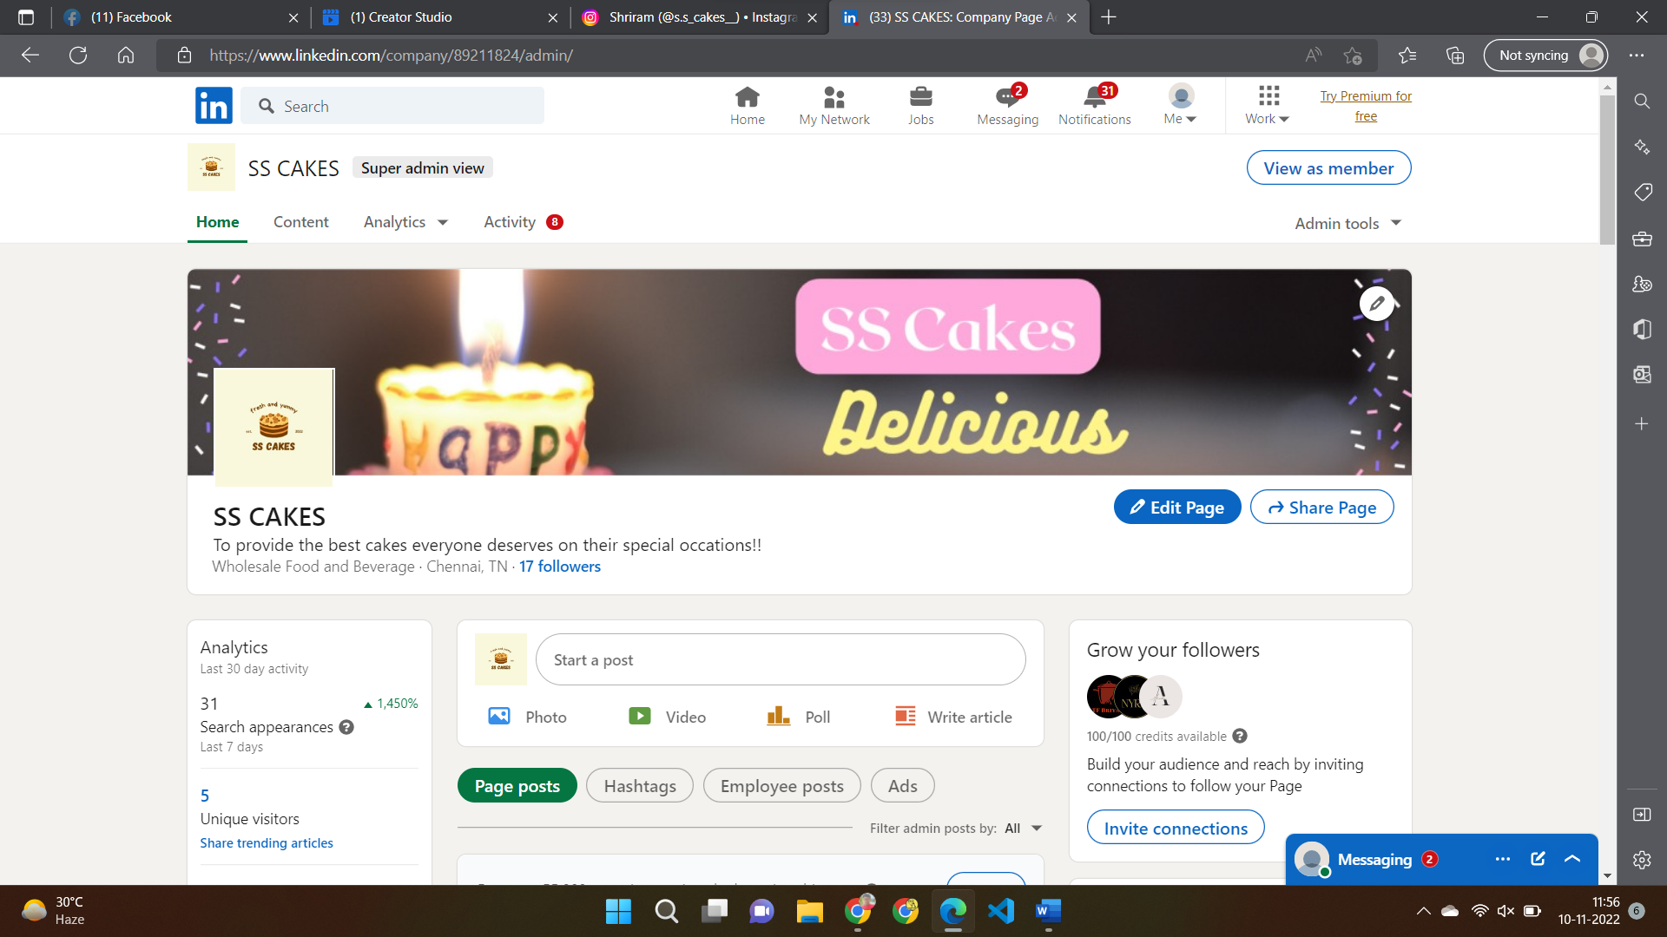

POSTERS AND VIDEOS USED:

1.Brand logo was created first to create a unique and it grabs attention, makes a strong first impression, is the foundation of the brand identity, is memorable, separates from competition, fosters brand loyalty, and is expected by your audience.

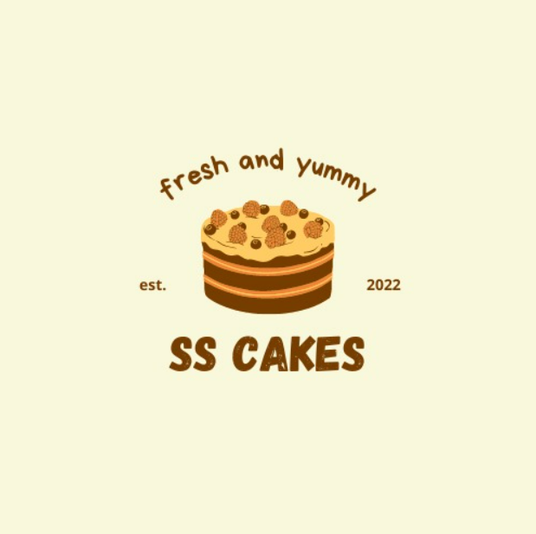

2.Sales posters were created to create awareness about the current offers and provide a logical and cost-effective way of communicating to a particular target market.



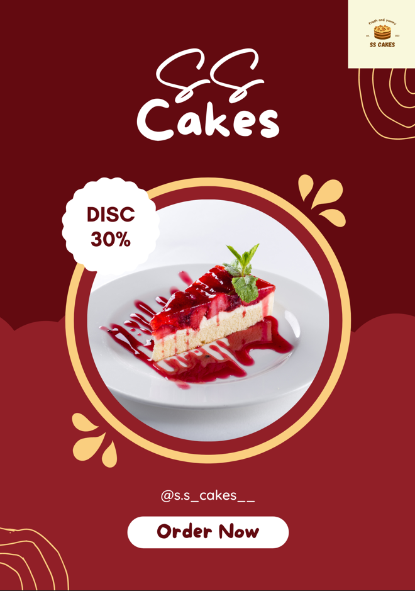

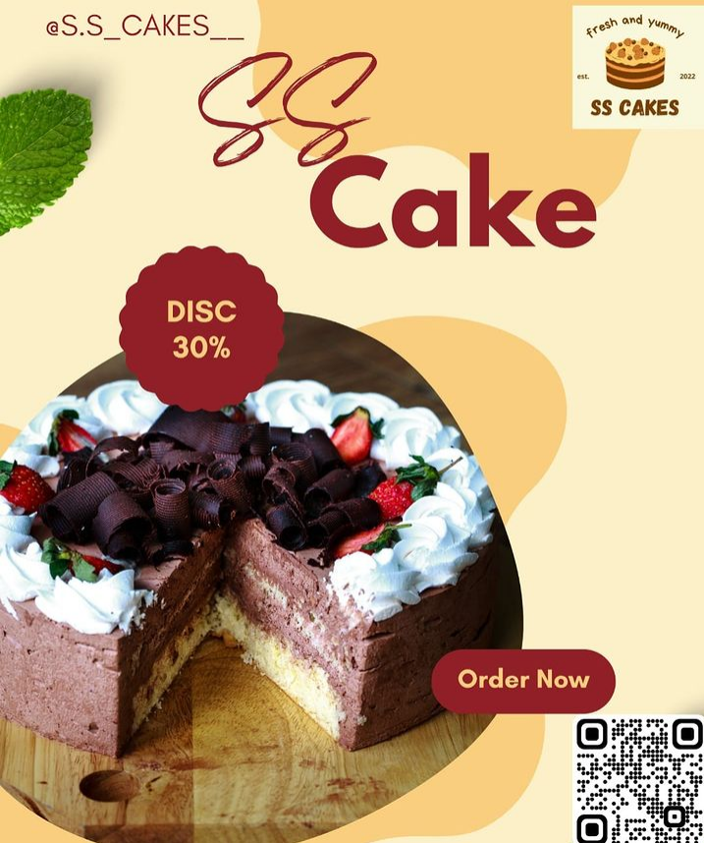

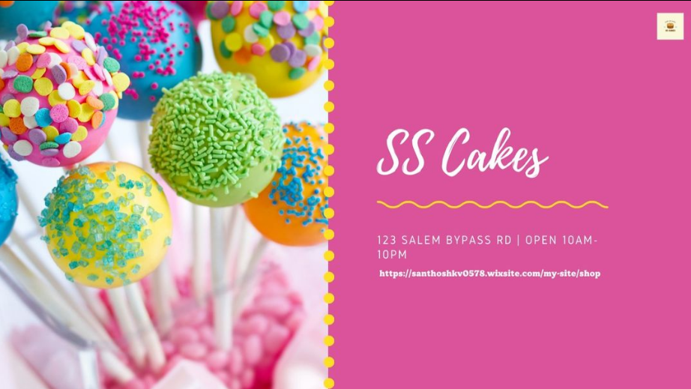

1. Videos were created in both reels(9:16) format and normal(1:1) format. Videos will be used to engage audience with the content as well as advertising our brand and the offers.

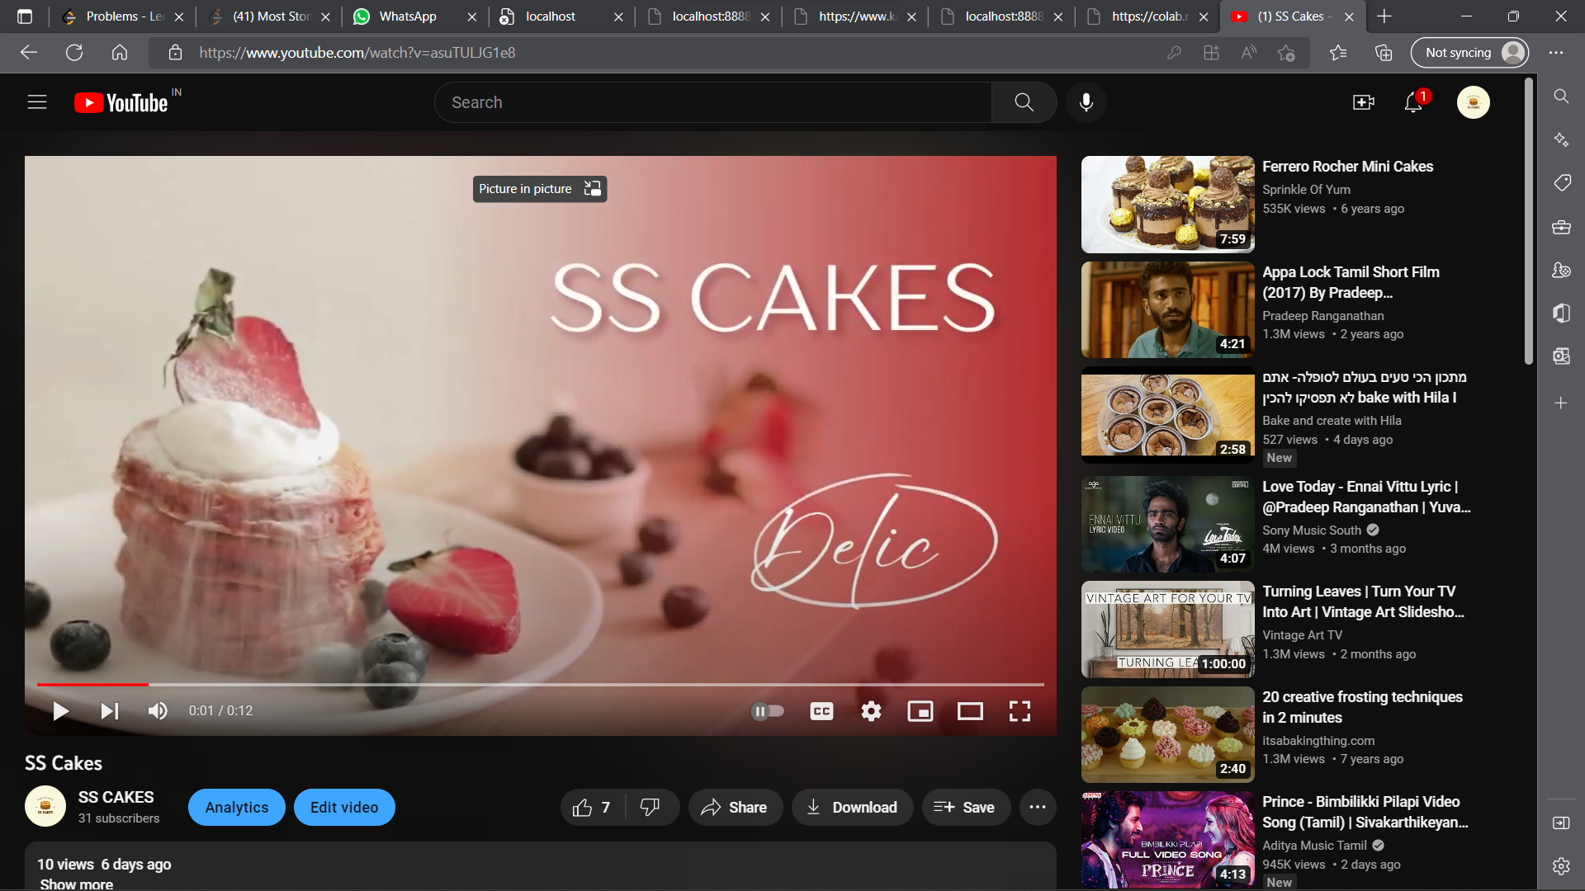

REF LINK: <https://youtu.be/asuTULJG1e8>

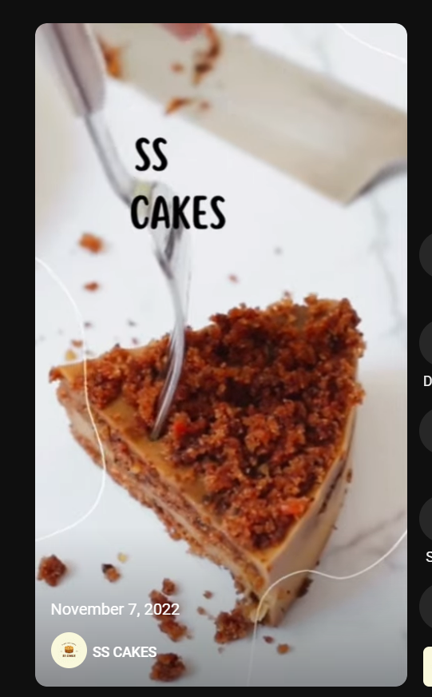

**REF LINK:** [**https://youtube.com/shorts/Bv7gH-NND7k?feature=share**](https://youtube.com/shorts/Bv7gH-NND7k?feature=share)

Promotion Strategy:

For promotion, we used “tags” which are in trend. These make our posts appear in the list of posts when searched for the particular tag. For instance, we have given a tag - #smartwatches and people search for it, our post appears and they visit our website and make purchase from there. This is one of the main kinds of promotional strategy used by our business. Other strategies include, promoting our business page to family and friends and their family and friends and therefore we get quite some reach in this method too. Promoting a brand is very difficult especially in this era. Digital marketing makes it simple as it helps everyone to promote their brand and products as the customers want through internet and social media. Through our methods, we were able to get reach in twitter only, and we did not get the expected reach in Facebook and Instagram.

We have also used SEO tools for optimising the web content along with submitting the website for priority queue for crawling so that our website is indexed in the search engines such as Google and Bing.

# DM CALENDAR:

First ASANA tool we used to create a DM CALENDAR:

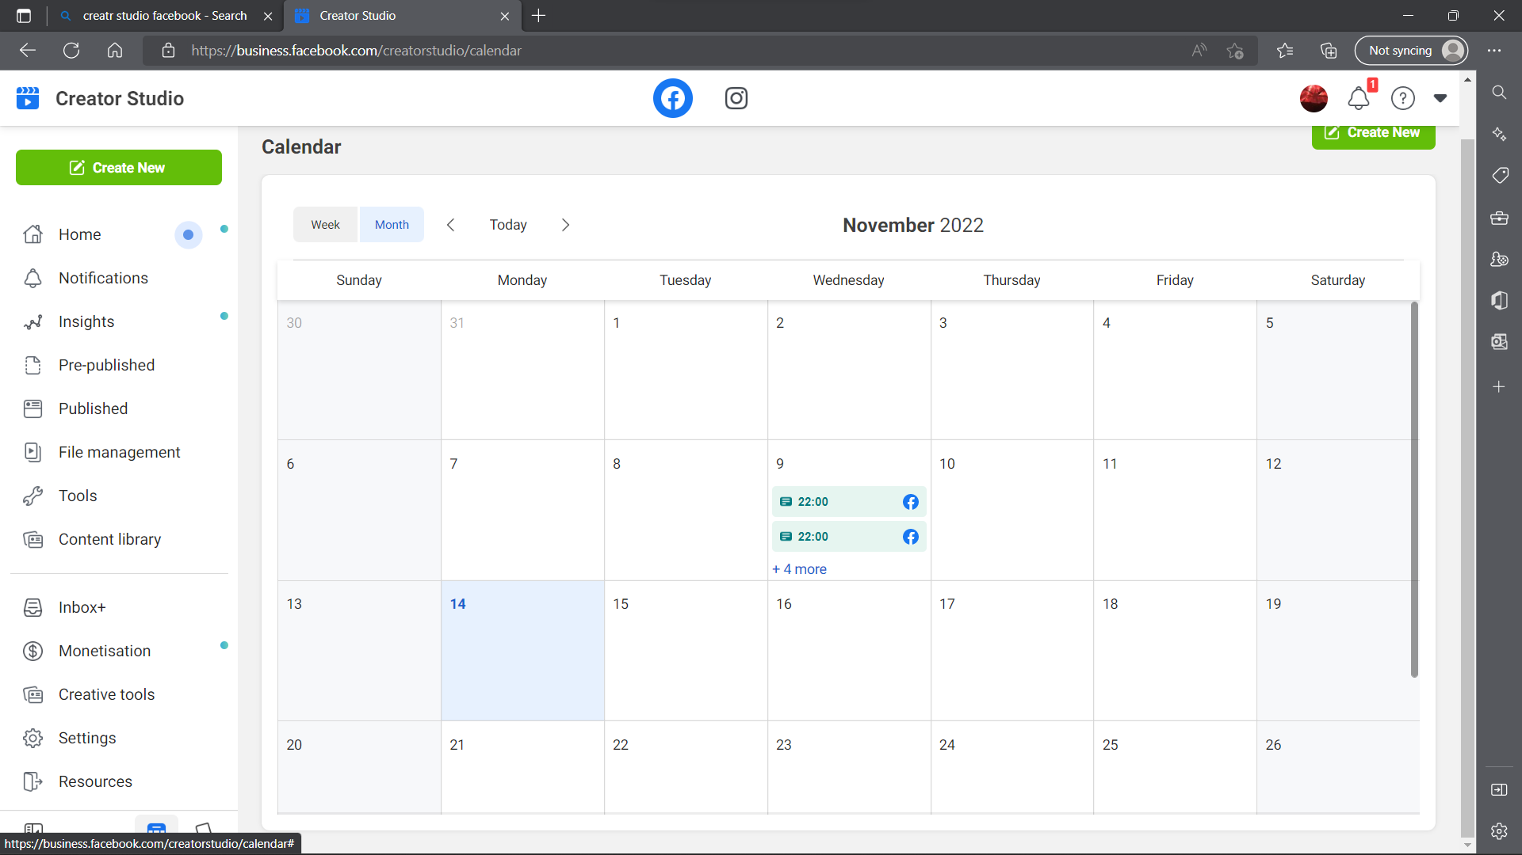

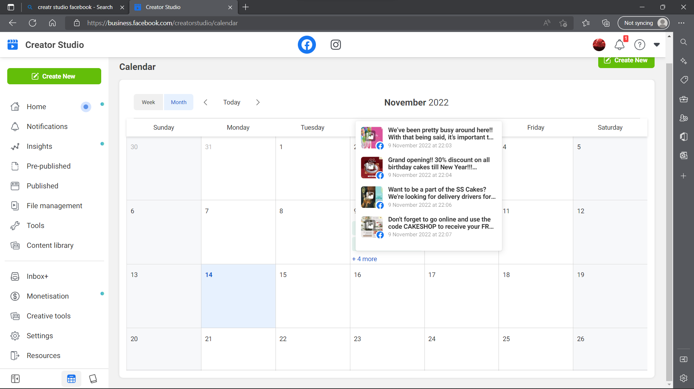

# RESULTS AND INFERENCE:

1. YOUTUBE ANALYTICS:

REF LINK: <https://www.youtube.com/channel/UCd-cs55hVlp8htO1wjEMrAQ>

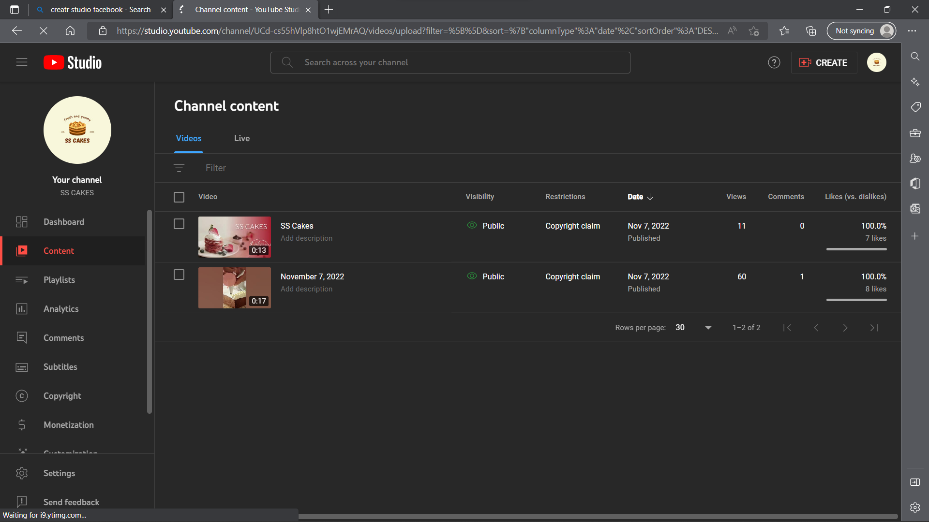

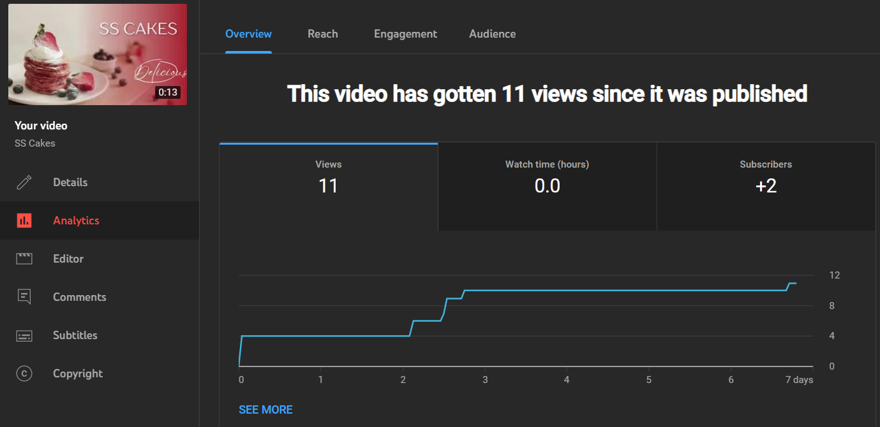

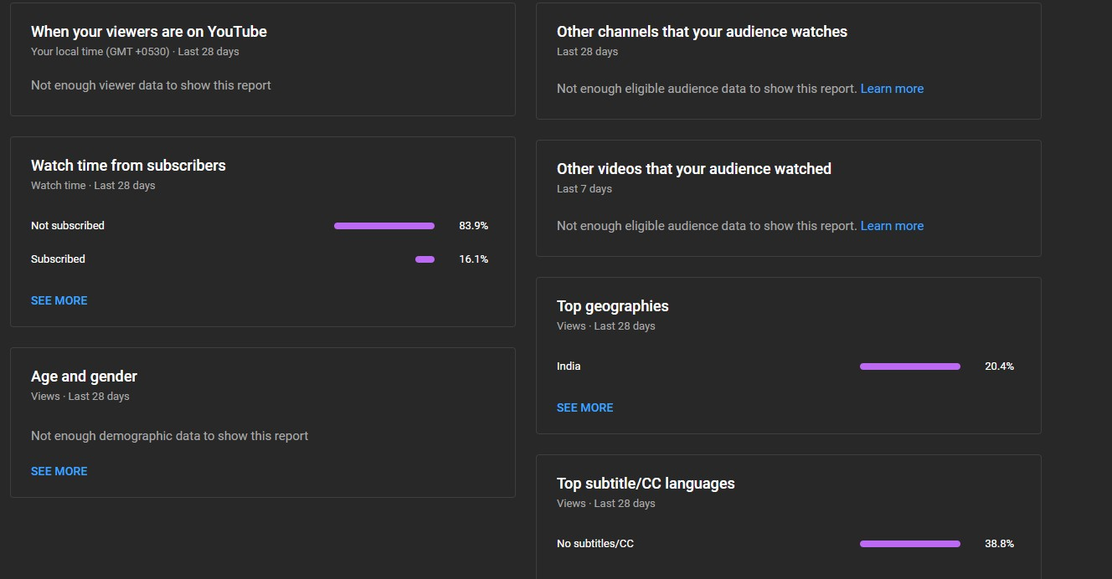

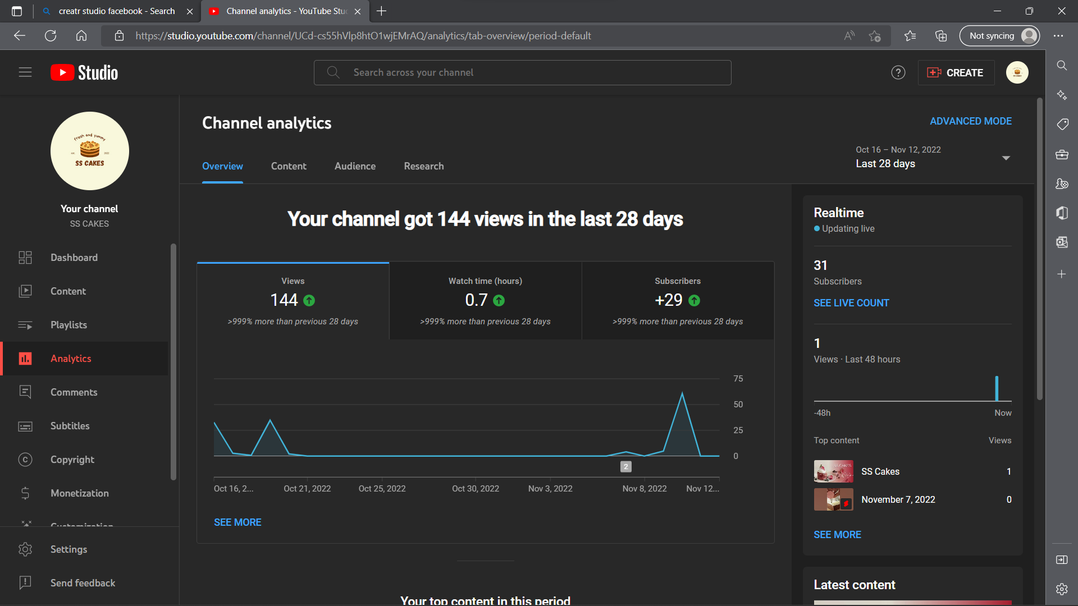

* + The channel has got 144 views from the two videos that was posted.
  + The subscribers and watch count has been comparatively increased after uploading a short.
  + Not subscribed viewers are more for the channel which means that our channel is performing well in terms of reach but poorly on conversions.
  + The audience retention time is 50% of the video which means that we have to focus more on creating engaging contents for the brand.

2.EMAIL MARKETING ANALYTICS:

MAIL REF LINK: <https://manage.wix.com/dashboard/0007fa16-eea2-4d6f-b450-35ce4007ba7c/shoutout/?referralInfo=dashboard_more_than_a_website#/dashboard>

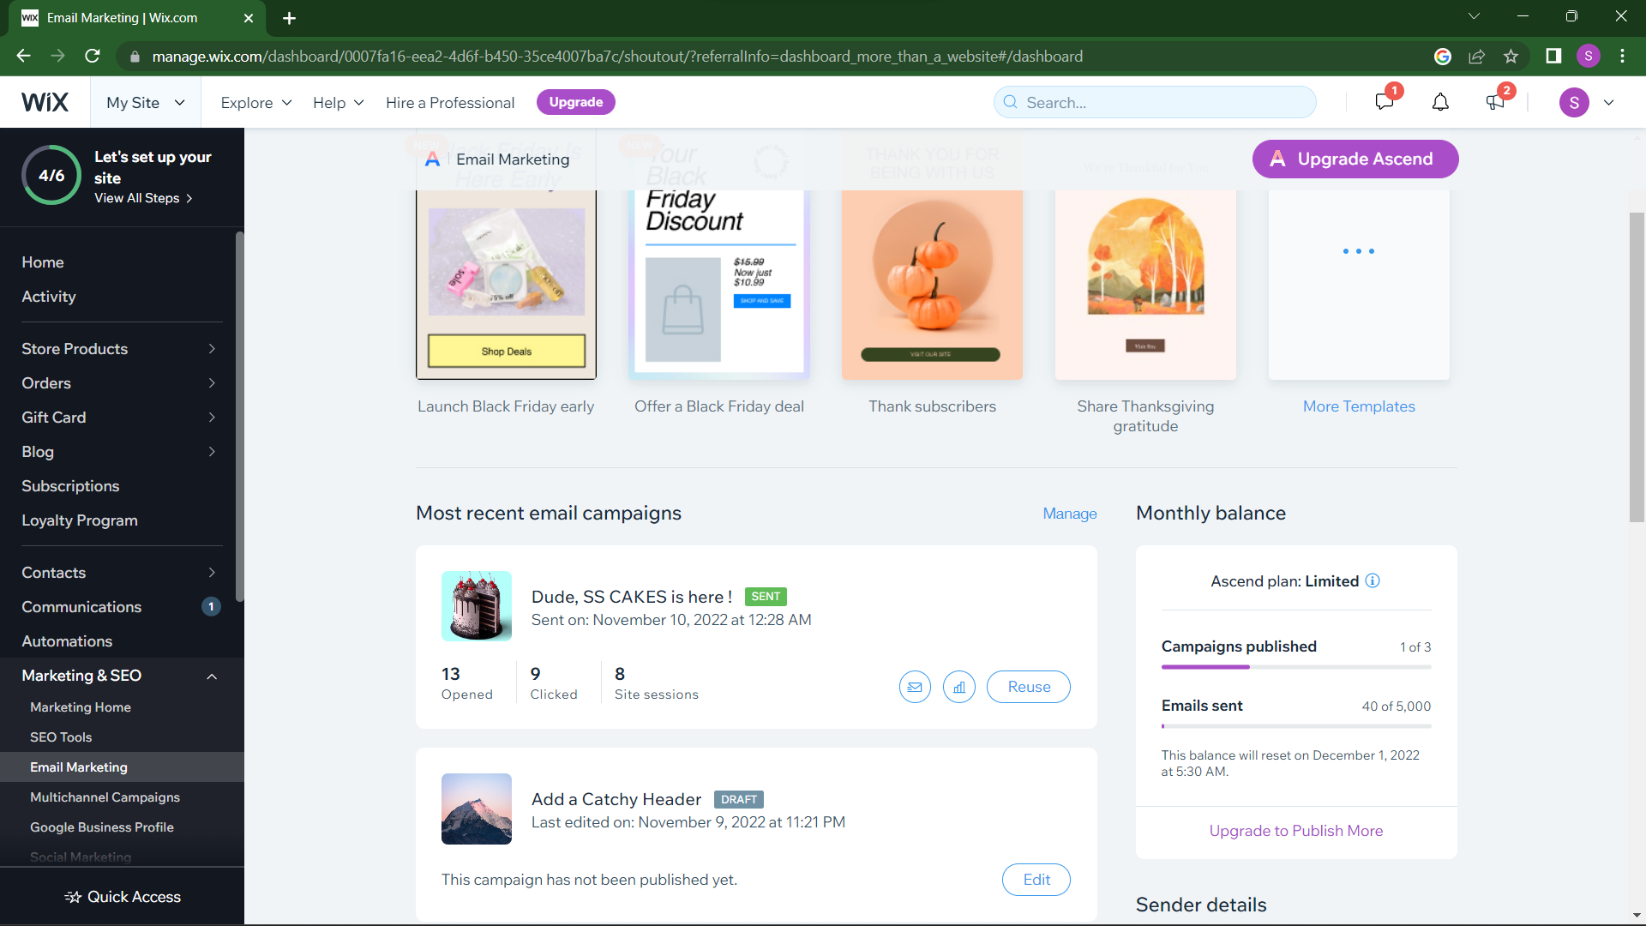

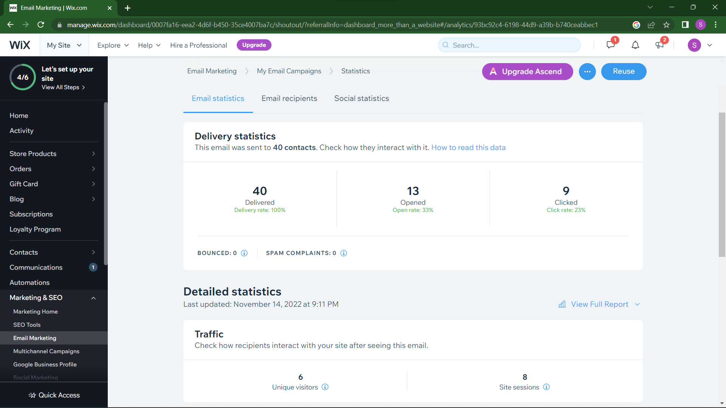

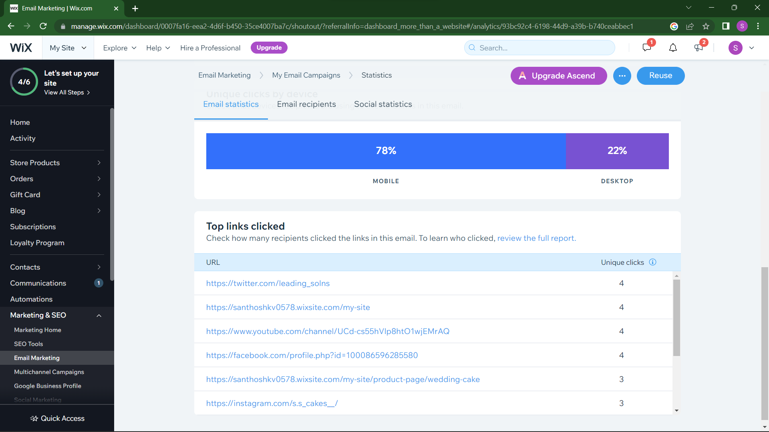

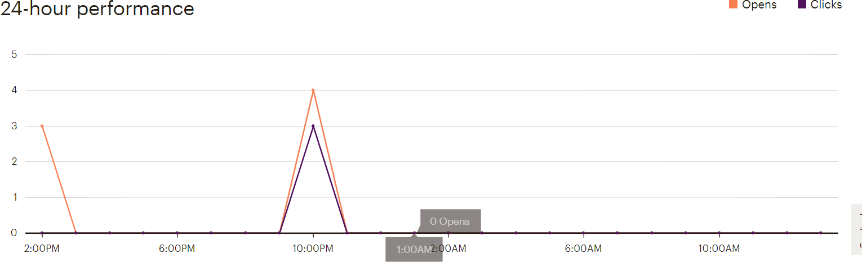

* + The email campaign has gone very poorly as the open and click rate is very low
  + Attractive subject lines must be kept so that the receivers will be interested to spend their time in opening the mail.
  + Social Media links and product’s image link clicks have been more indicating that few

customers were interested in the product and the website.

* + Past 24 hours performance shows that the mail was opened frequently on 10:00pm to 11 : 00 pm which can be considered as the active time of subscribers and the future mail campaigns must be sent considering this time period for better outcome.

3.Facebook Marketing:

REF LINK: https://www.facebook.com/profile.php?id=100086596285580

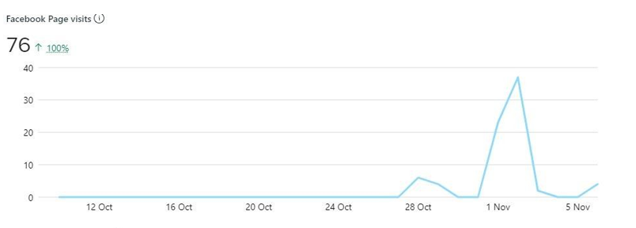

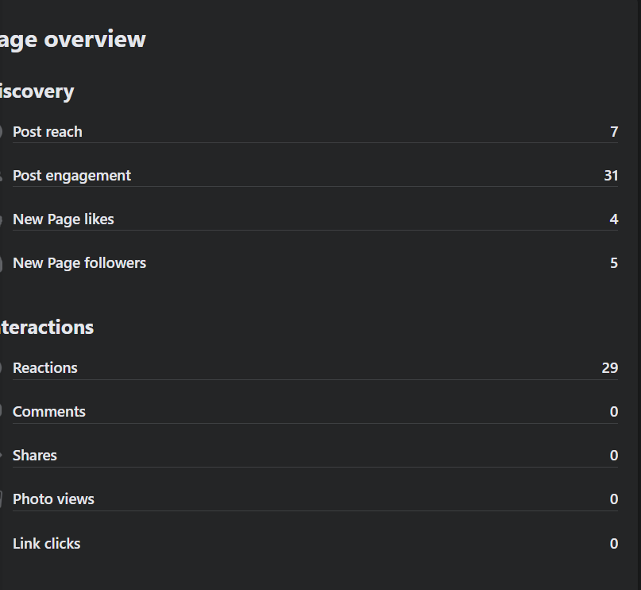

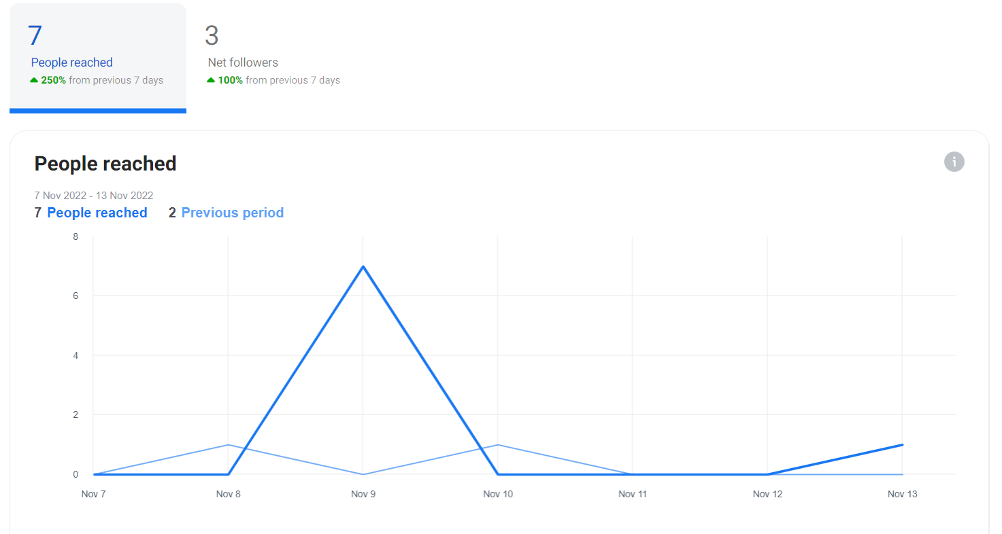

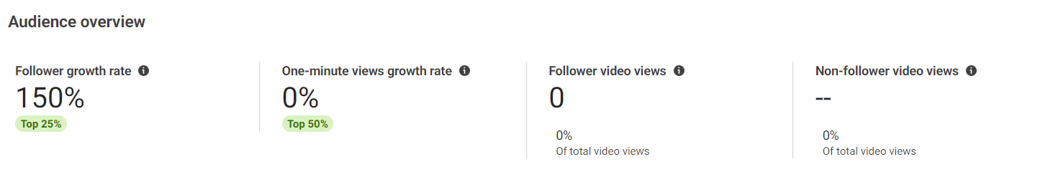

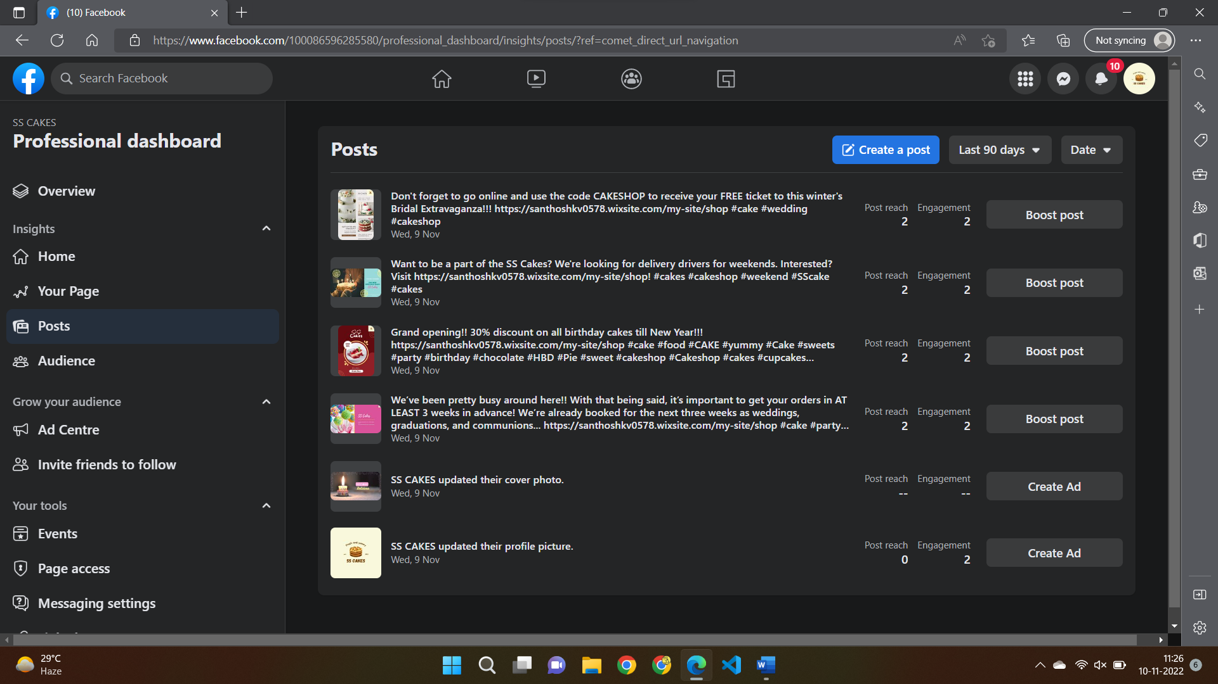

* Facebook page has a decent page visit which is considered to be a good start for the page.
* The top post has 6 engagements and overall posts has only 14 engagements which is again very low, thus the page must reconsider their content and digitals marketing strategy for Facebook.
* The link clicks for the page have 0 metrics which is very poor thus more compelling contents has to be posted to gain more customer traffic to the website.
* Thus, changing of marketing strategy and creating new engaging content is strictly recommended and will be followed from today.

4.Instagarm Marketing:

REF LINK: <https://www.instagram.com/s.s_cakes__/>



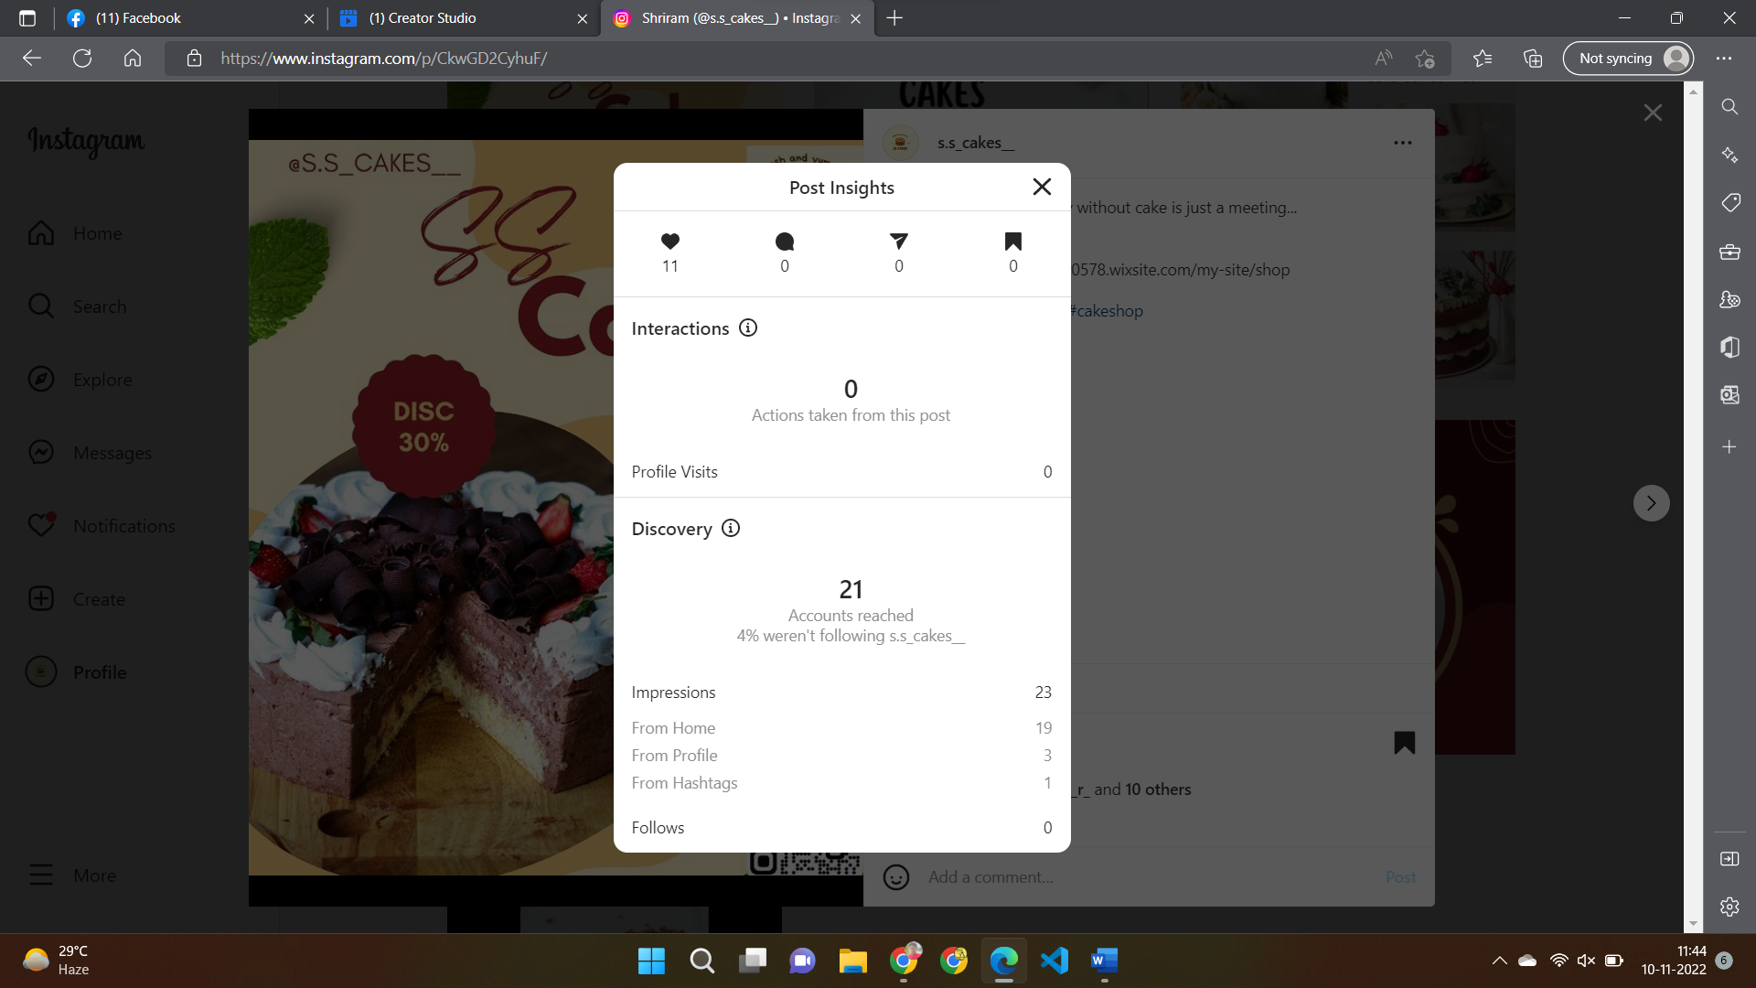

META CREATOR INSTAGRAM

Post

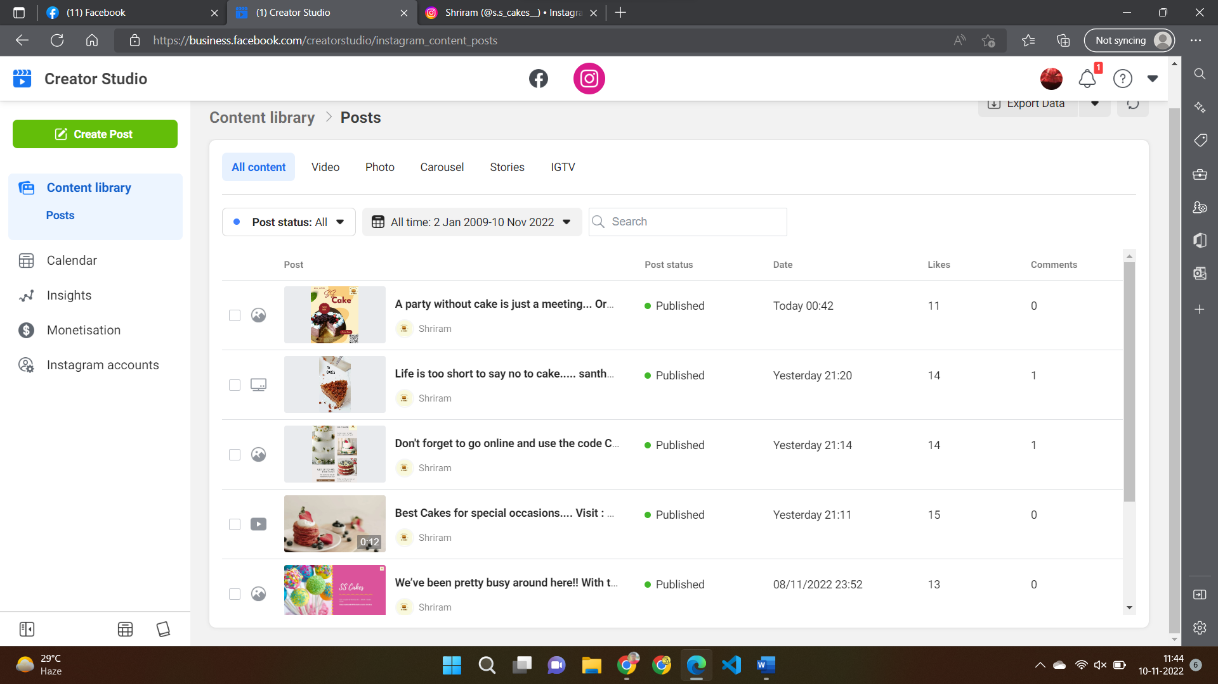

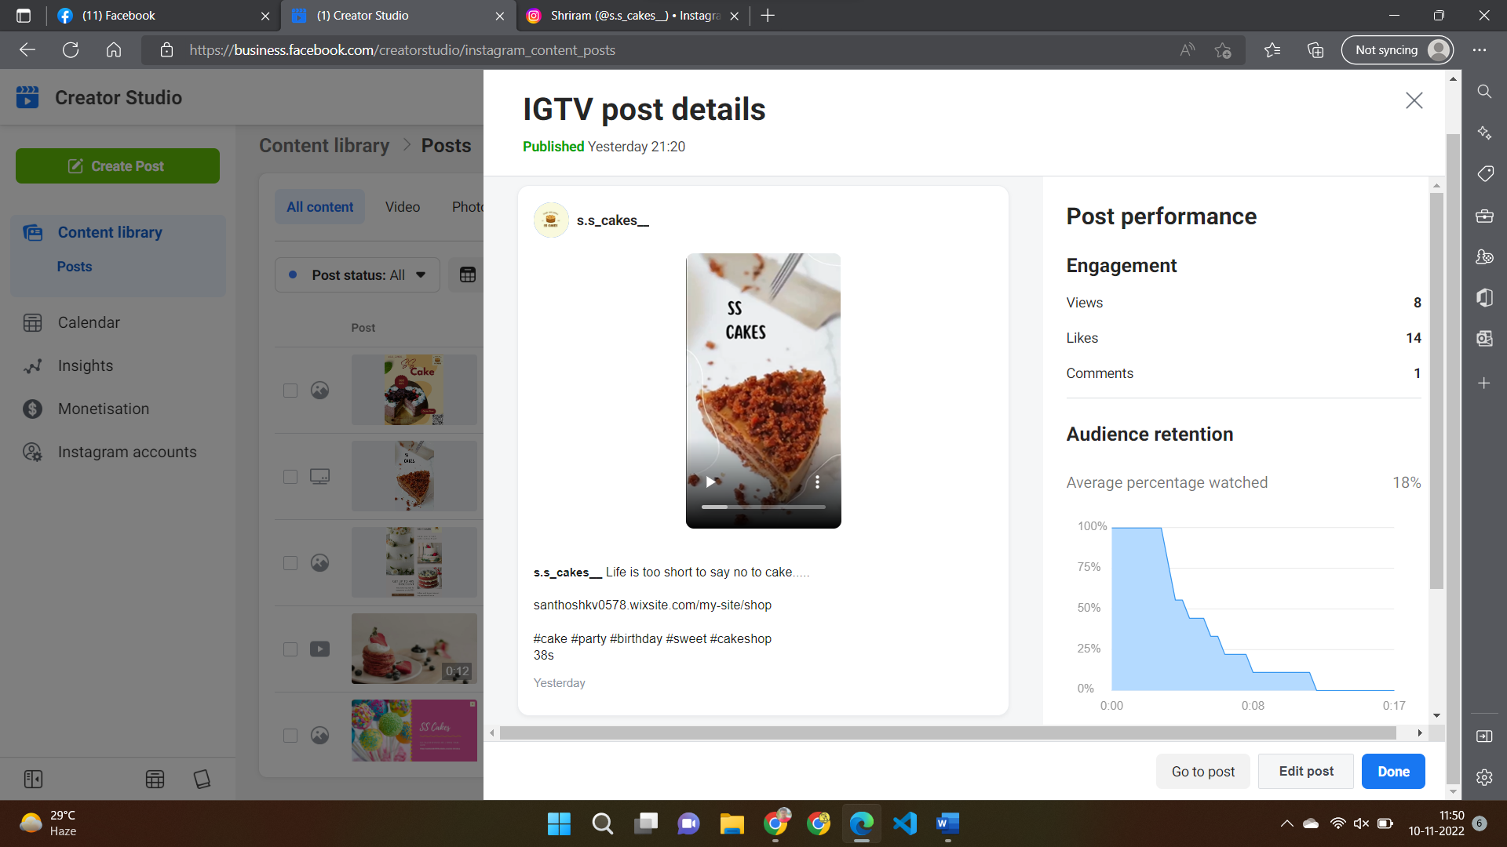

Insights -> Activity

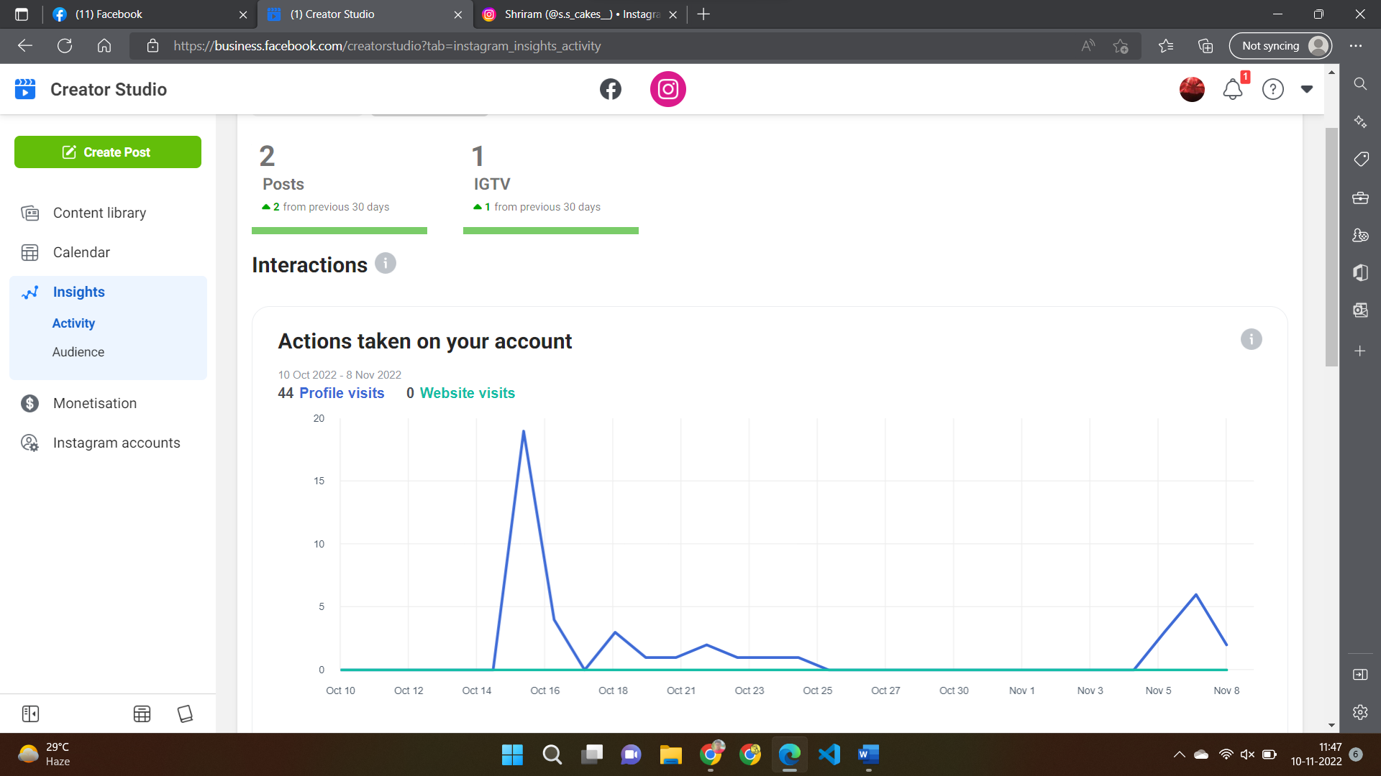

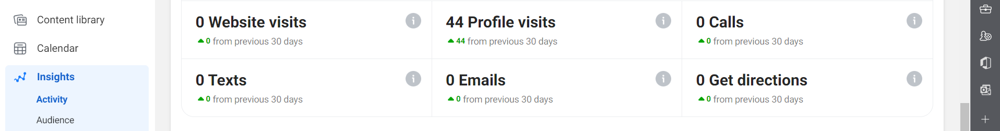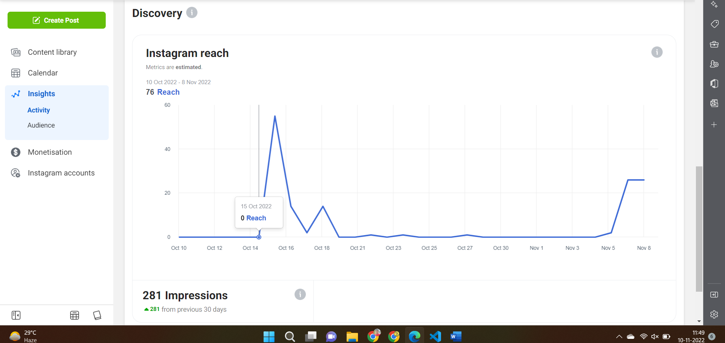

* + Instagram page reach has been extremely good as 70 accounts has been reached within 2 weeks of the account creation.
  + The content reach has been more toward the non followers and we must convince them to follow us by regularly posting on the app,so that brand awareness and sales would increase.
  + Website taps is comparably poor and must focus on the conversion rates by improving the content and trying out Instagram ads and advertising offers on the website.
  + Posts with hashtags have more reach than the post without hashtags thus adding relevant hashtags would boost the post impressions .

5.LINKEDIN MARKETING:

REF LINKhttps://www.linkedin.com/company/apk-digitals/



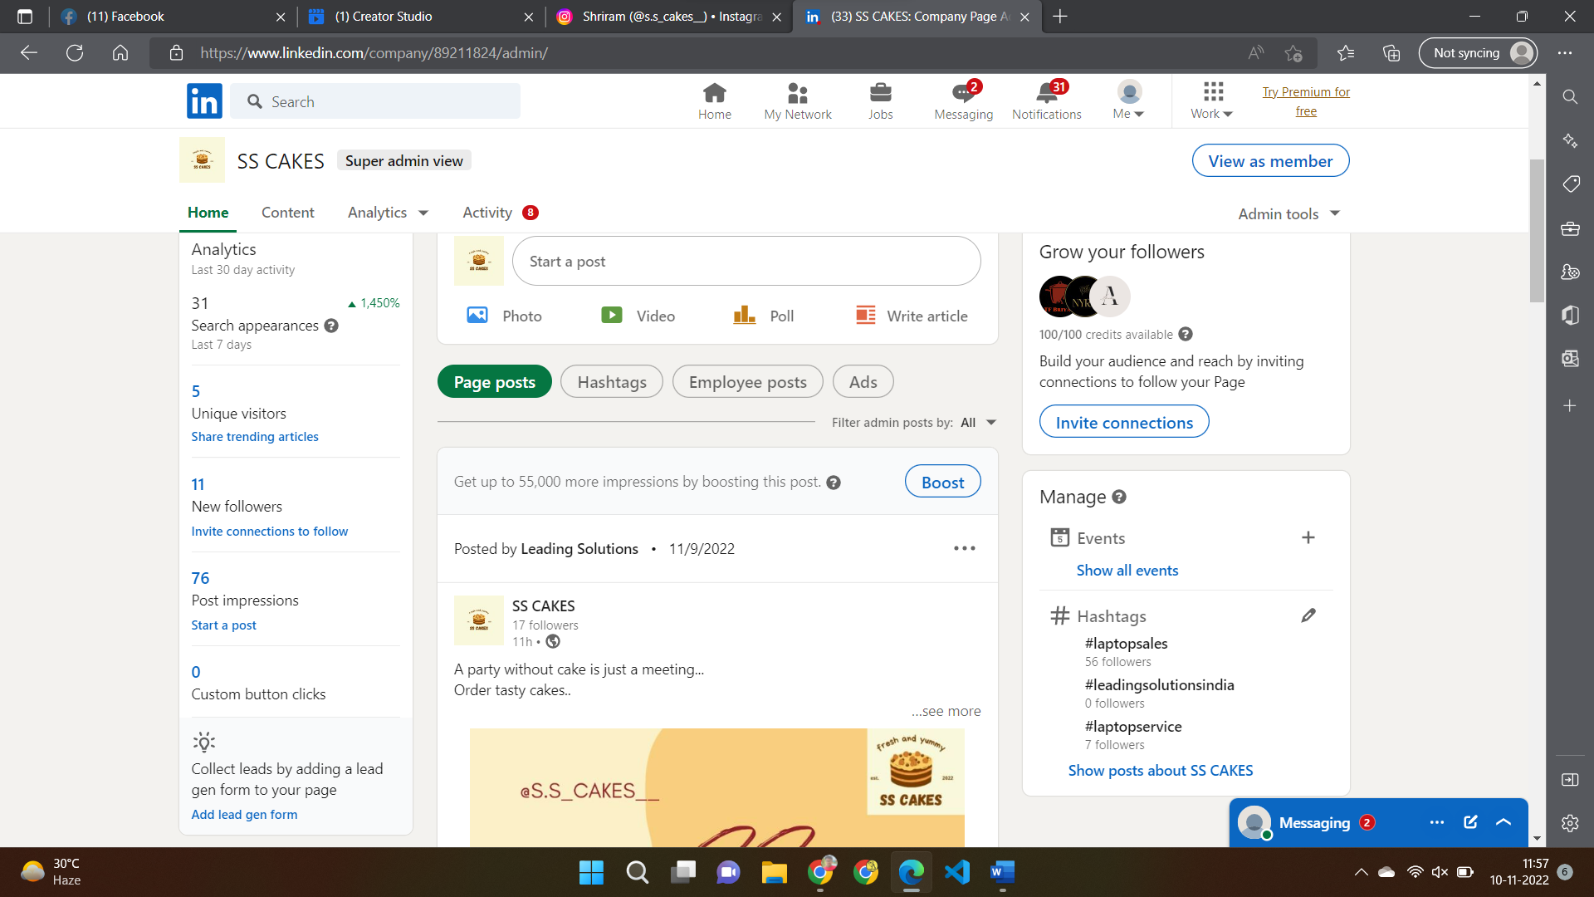

Analytics -> Visitors

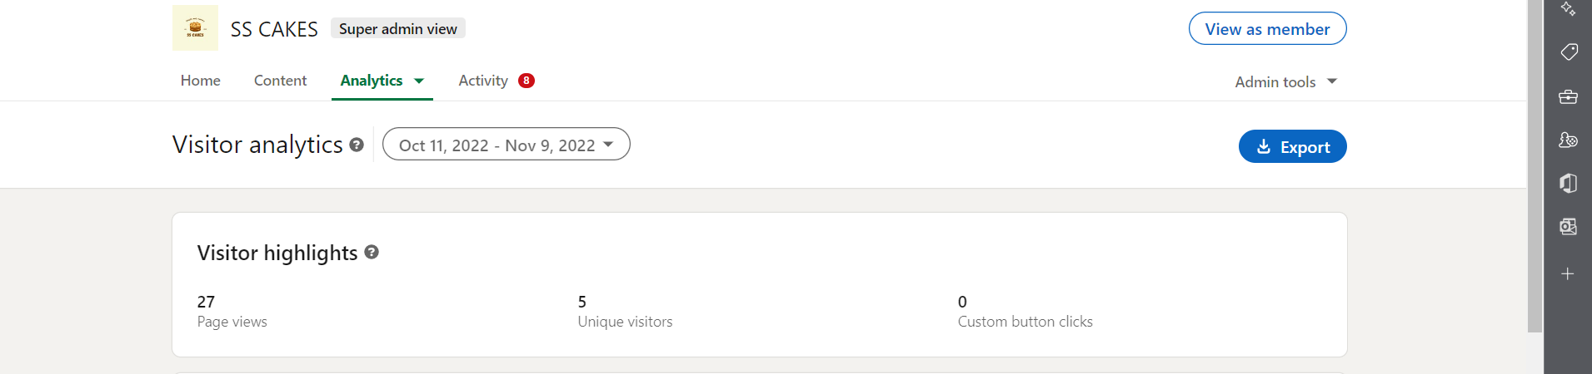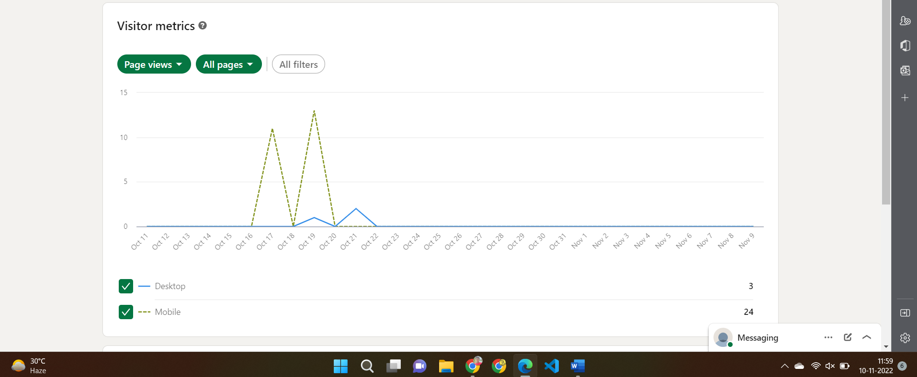

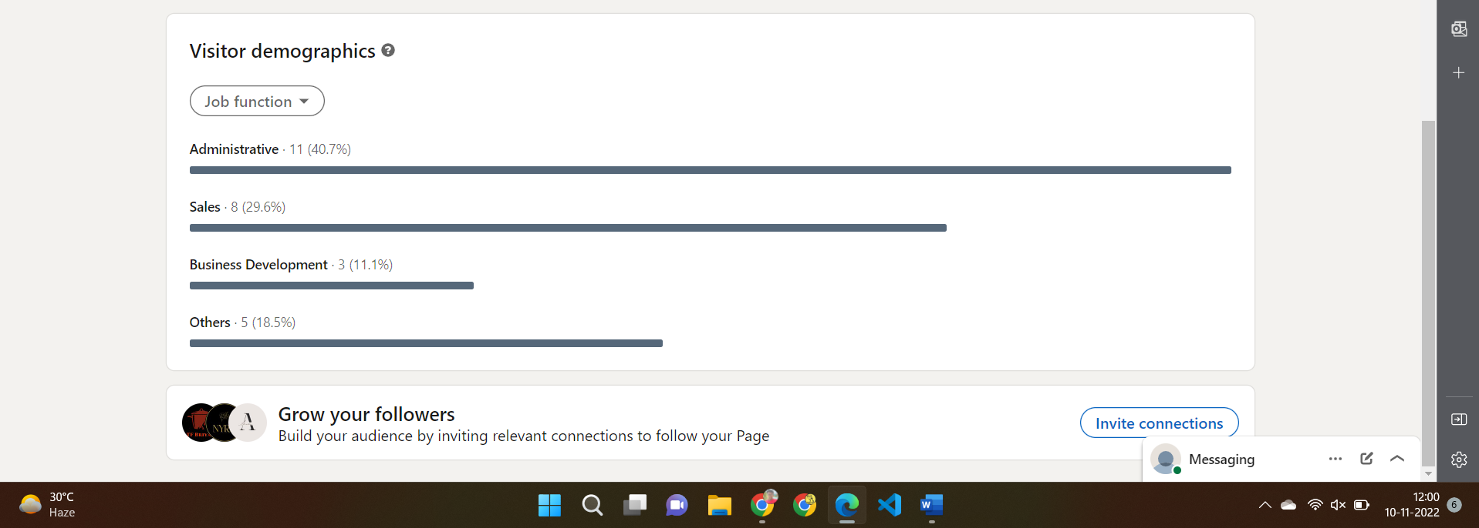

Analytics -> Followers

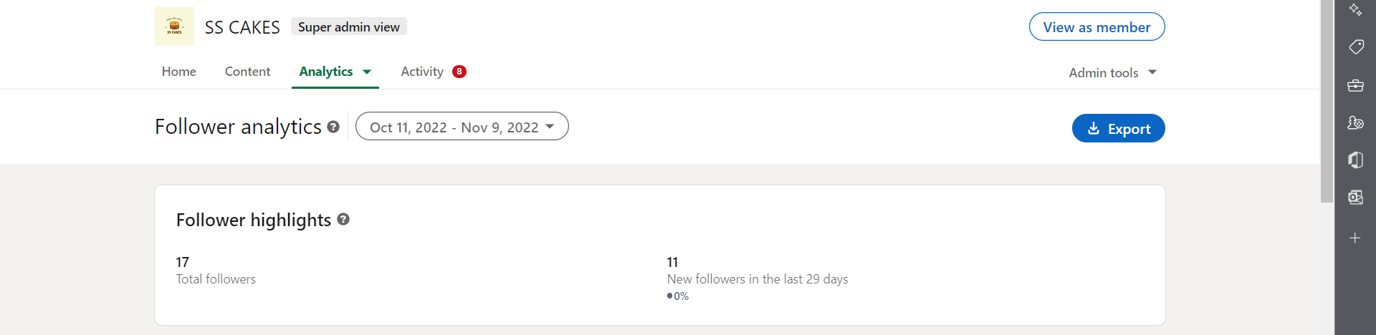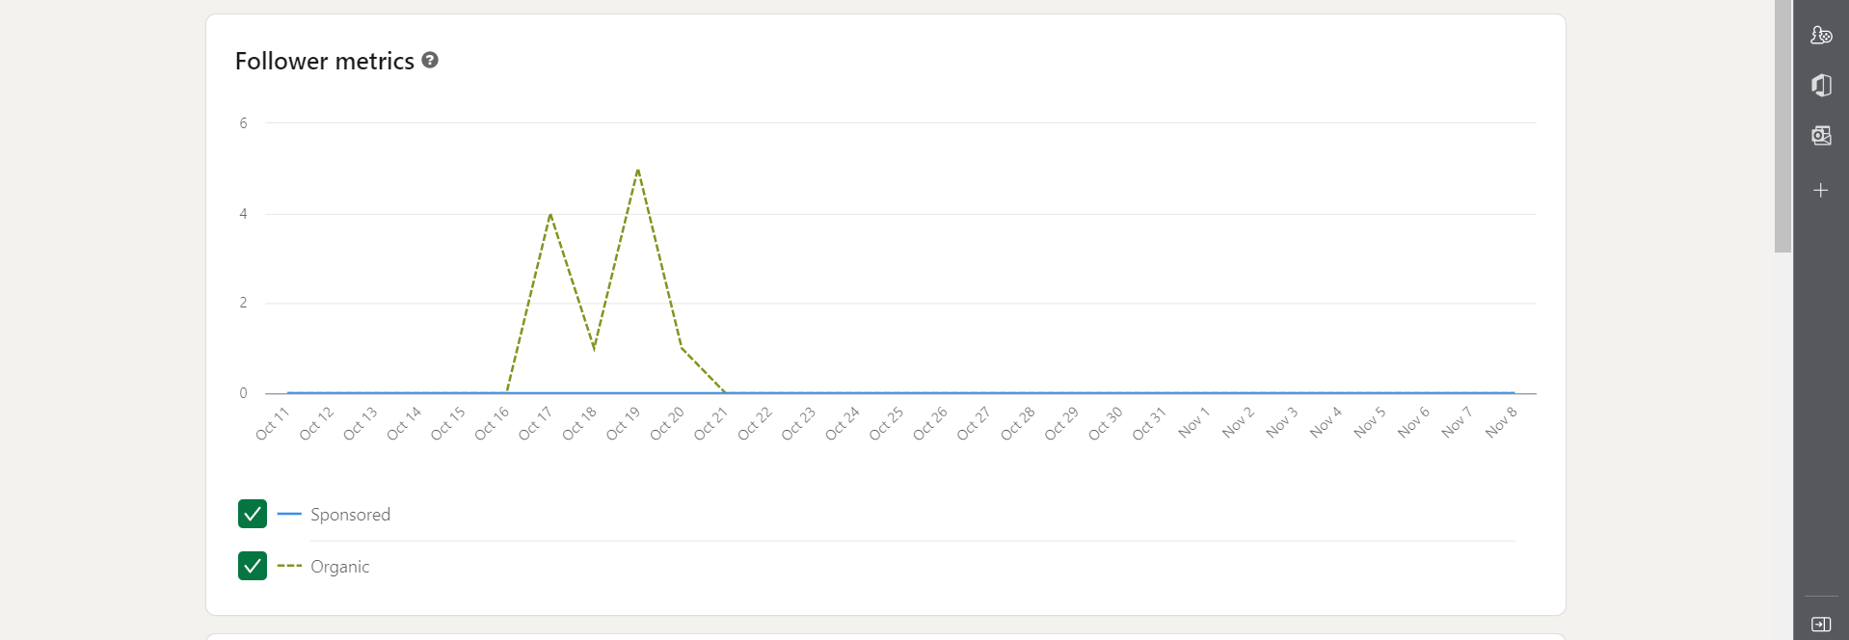

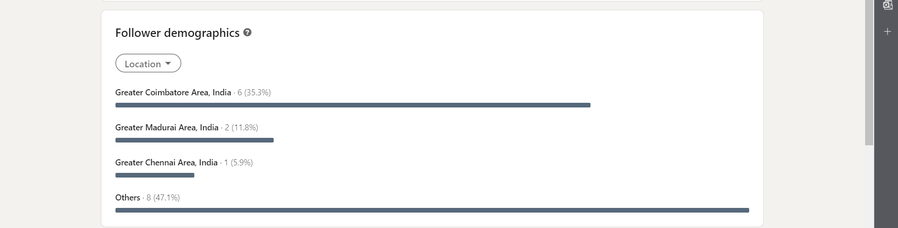

Analytics -> Content

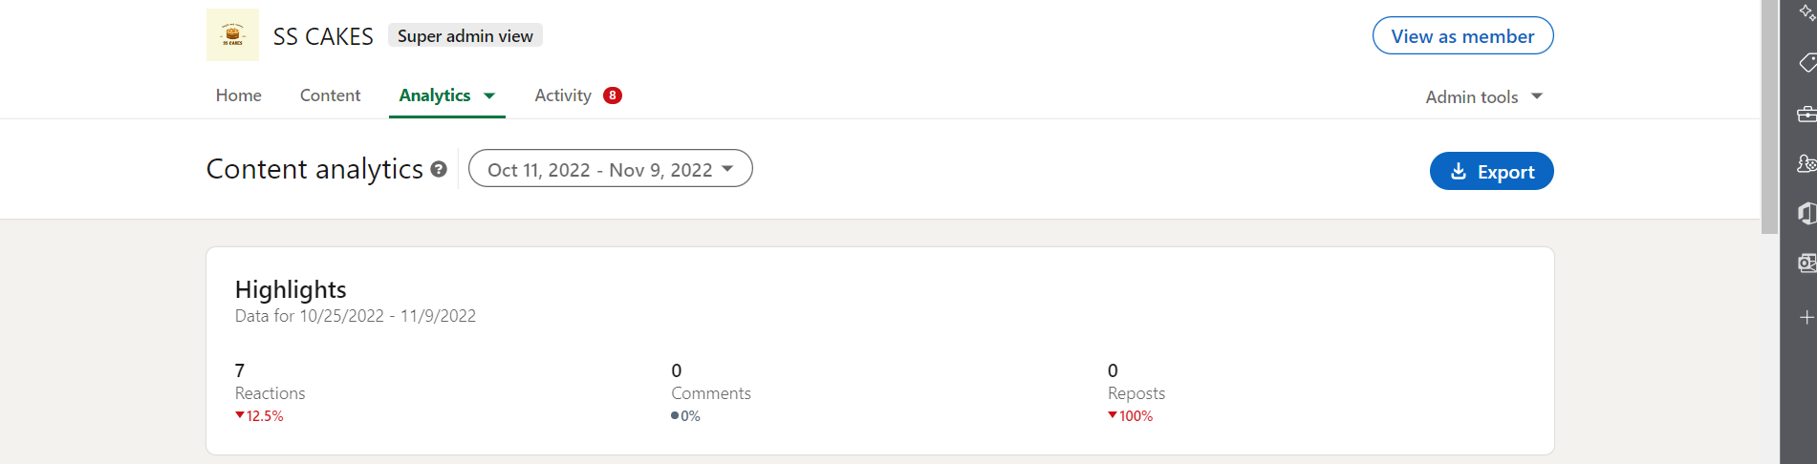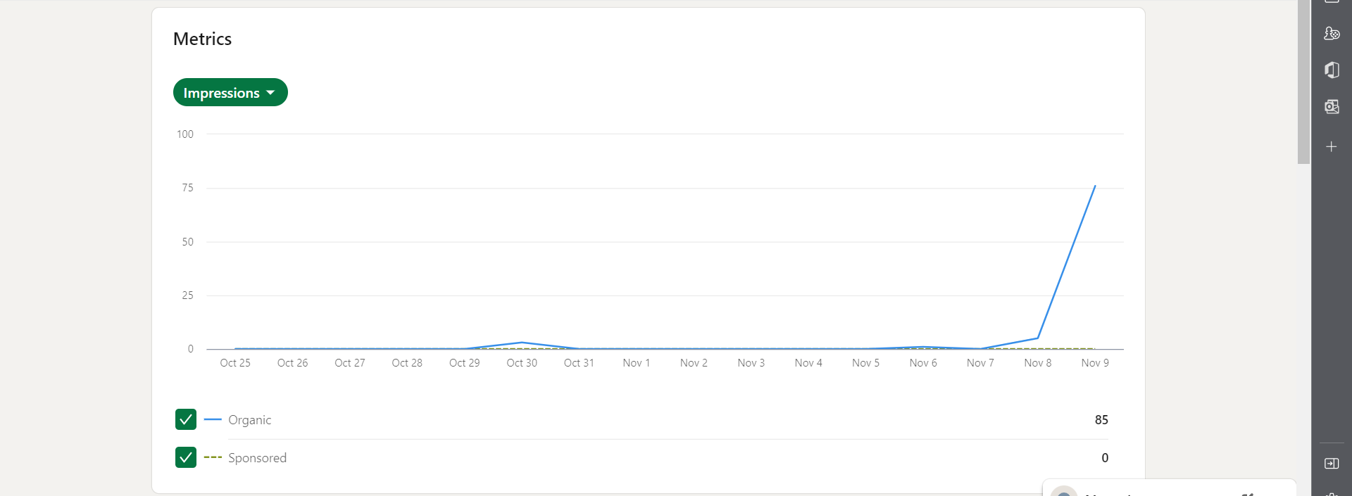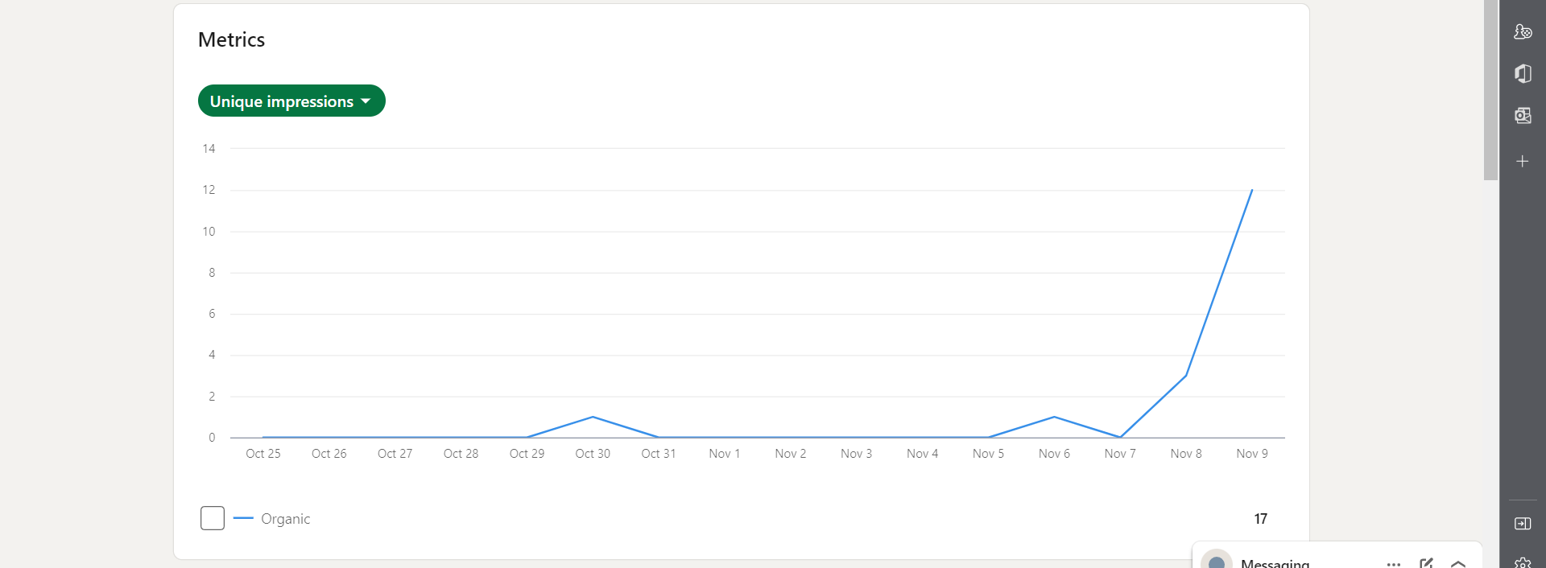

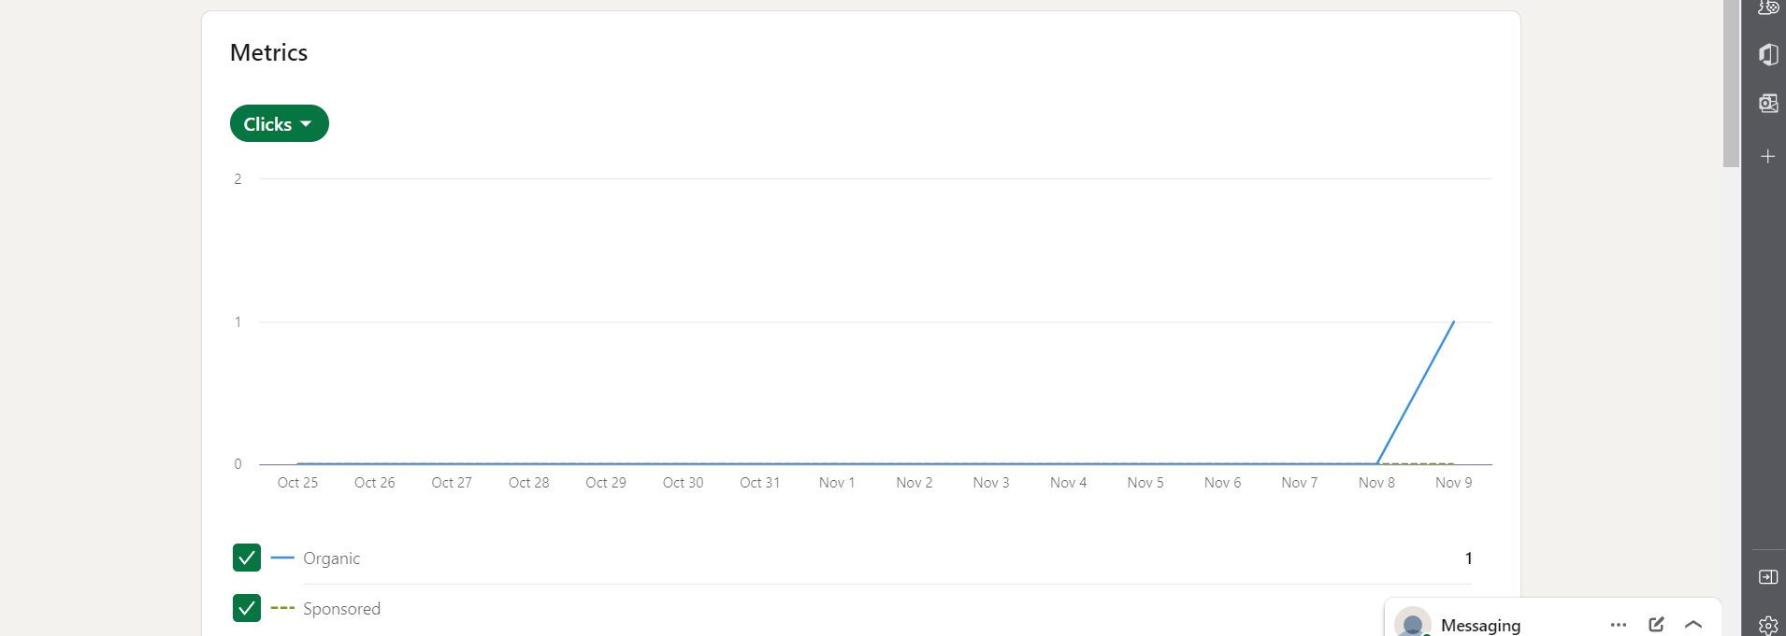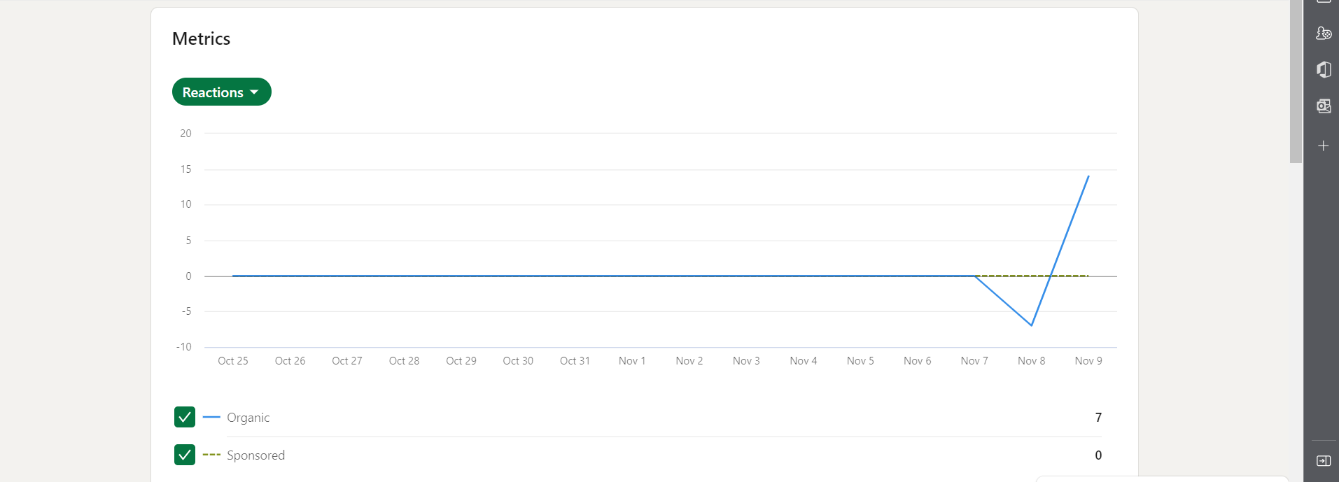

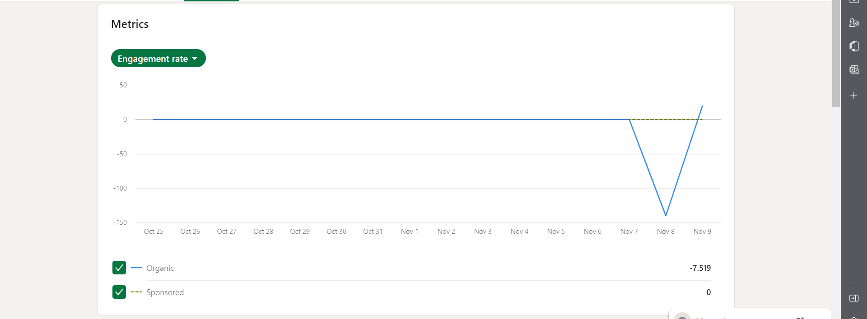

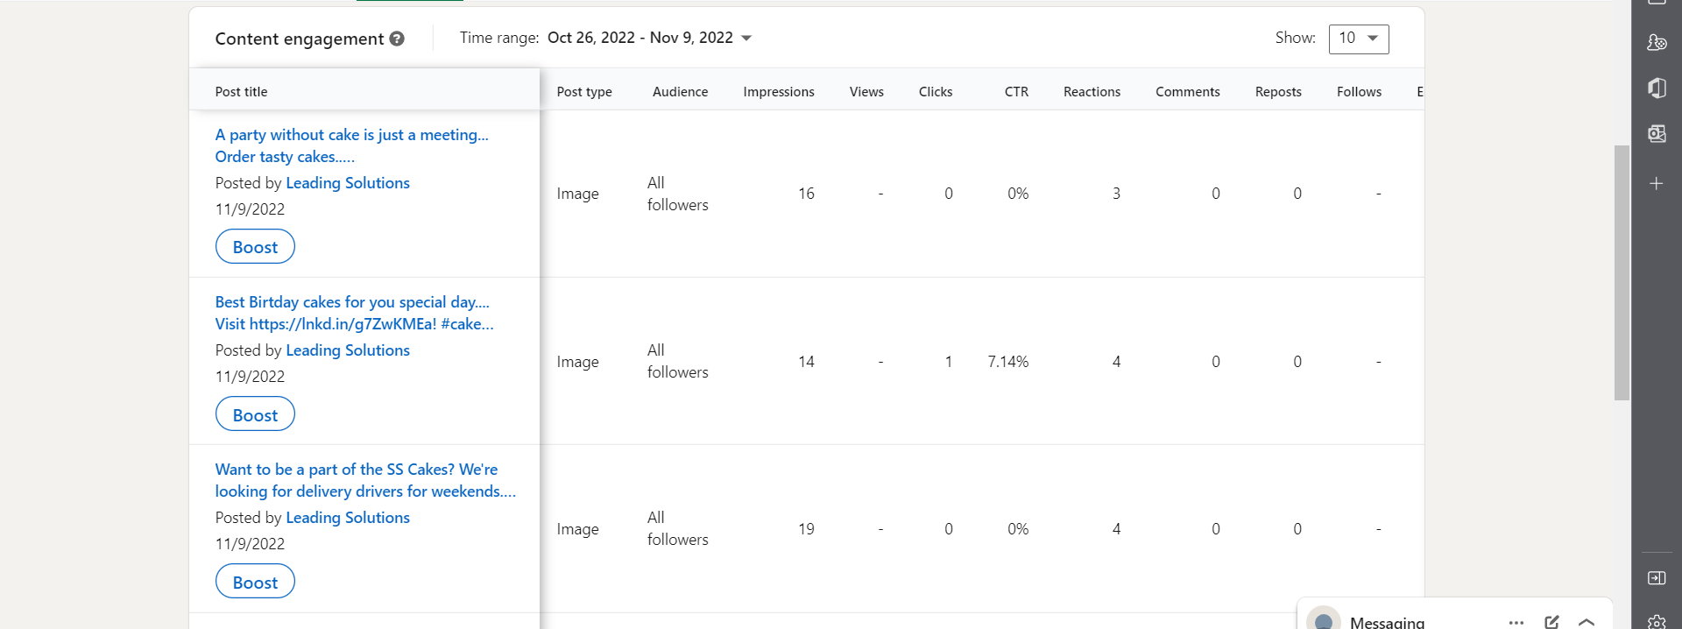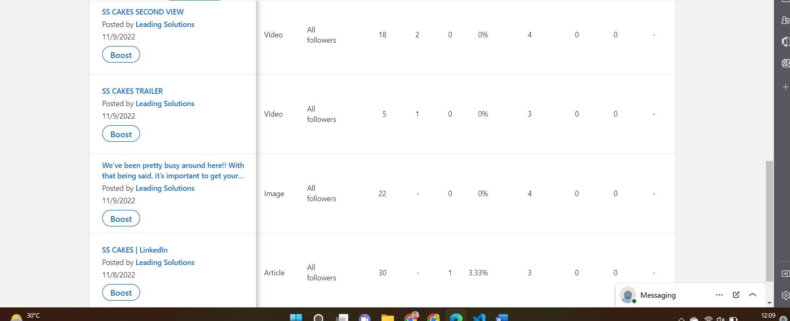

Activity

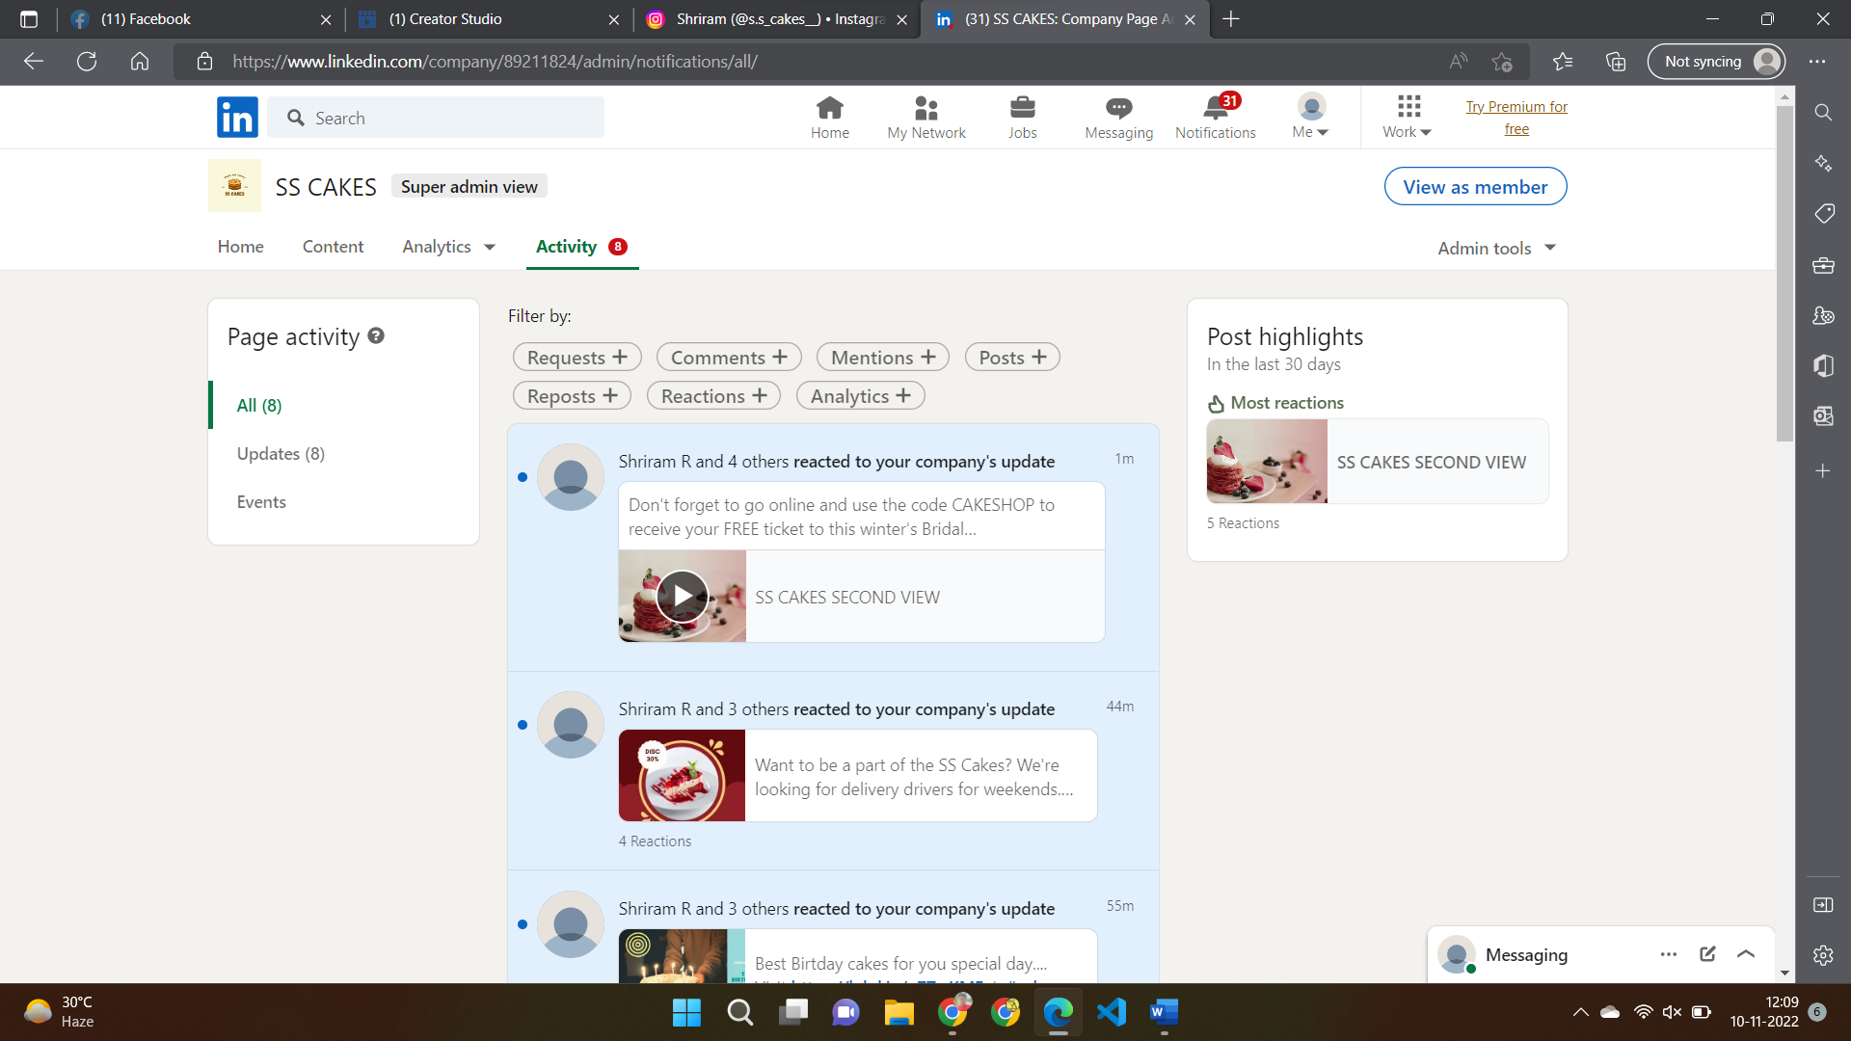

* + The engagement has been extremely good for a 2-week-old account and the similar type of content ideas and methods can be continued as graph only shows upward
  + The website taps and other CTAs has a low figure suggesting a better idea to compel the audience to increase the conversion rate.
  + The visitor and follower growth has been stable and consistent in all days which is a good sign and must be maintained so that there will be consistent growth even in future.
  + Impressions,vistiors to followers conversion rate and other metrics seems good and only CTAs has to be improved in LinkedIn Marketing.

6.Twitter Marketing:

REF LINK: <https://twitter.com/leading_solns>

Profile



Creator studio -> Analytics -> Home

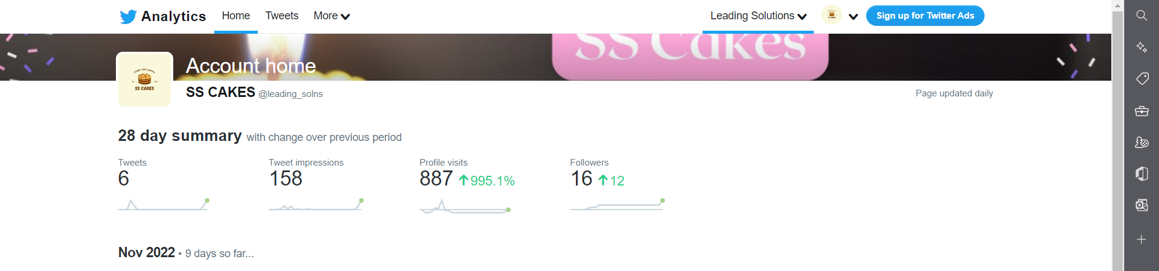

Analytics -> Tweets

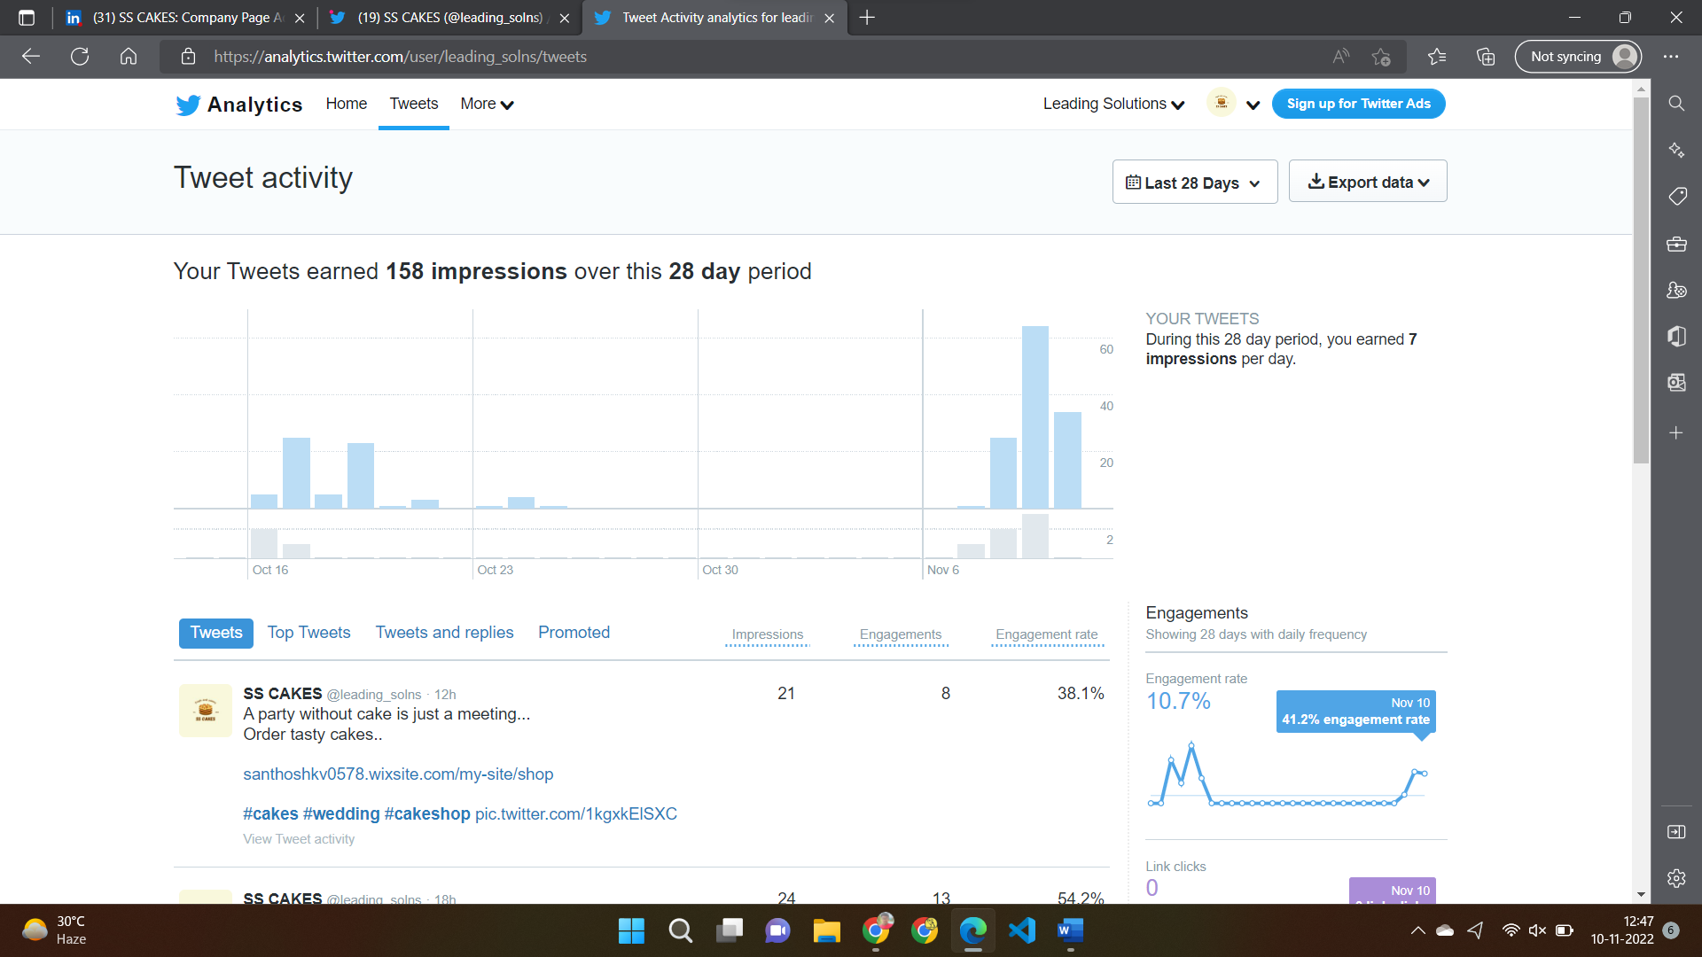

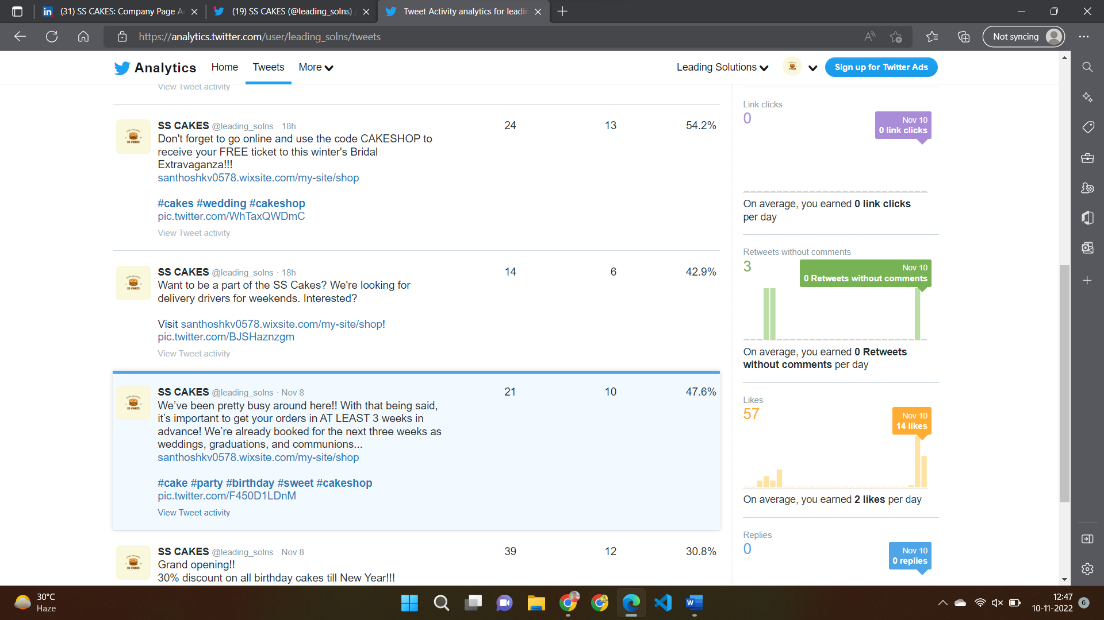

Analytics-> Videos

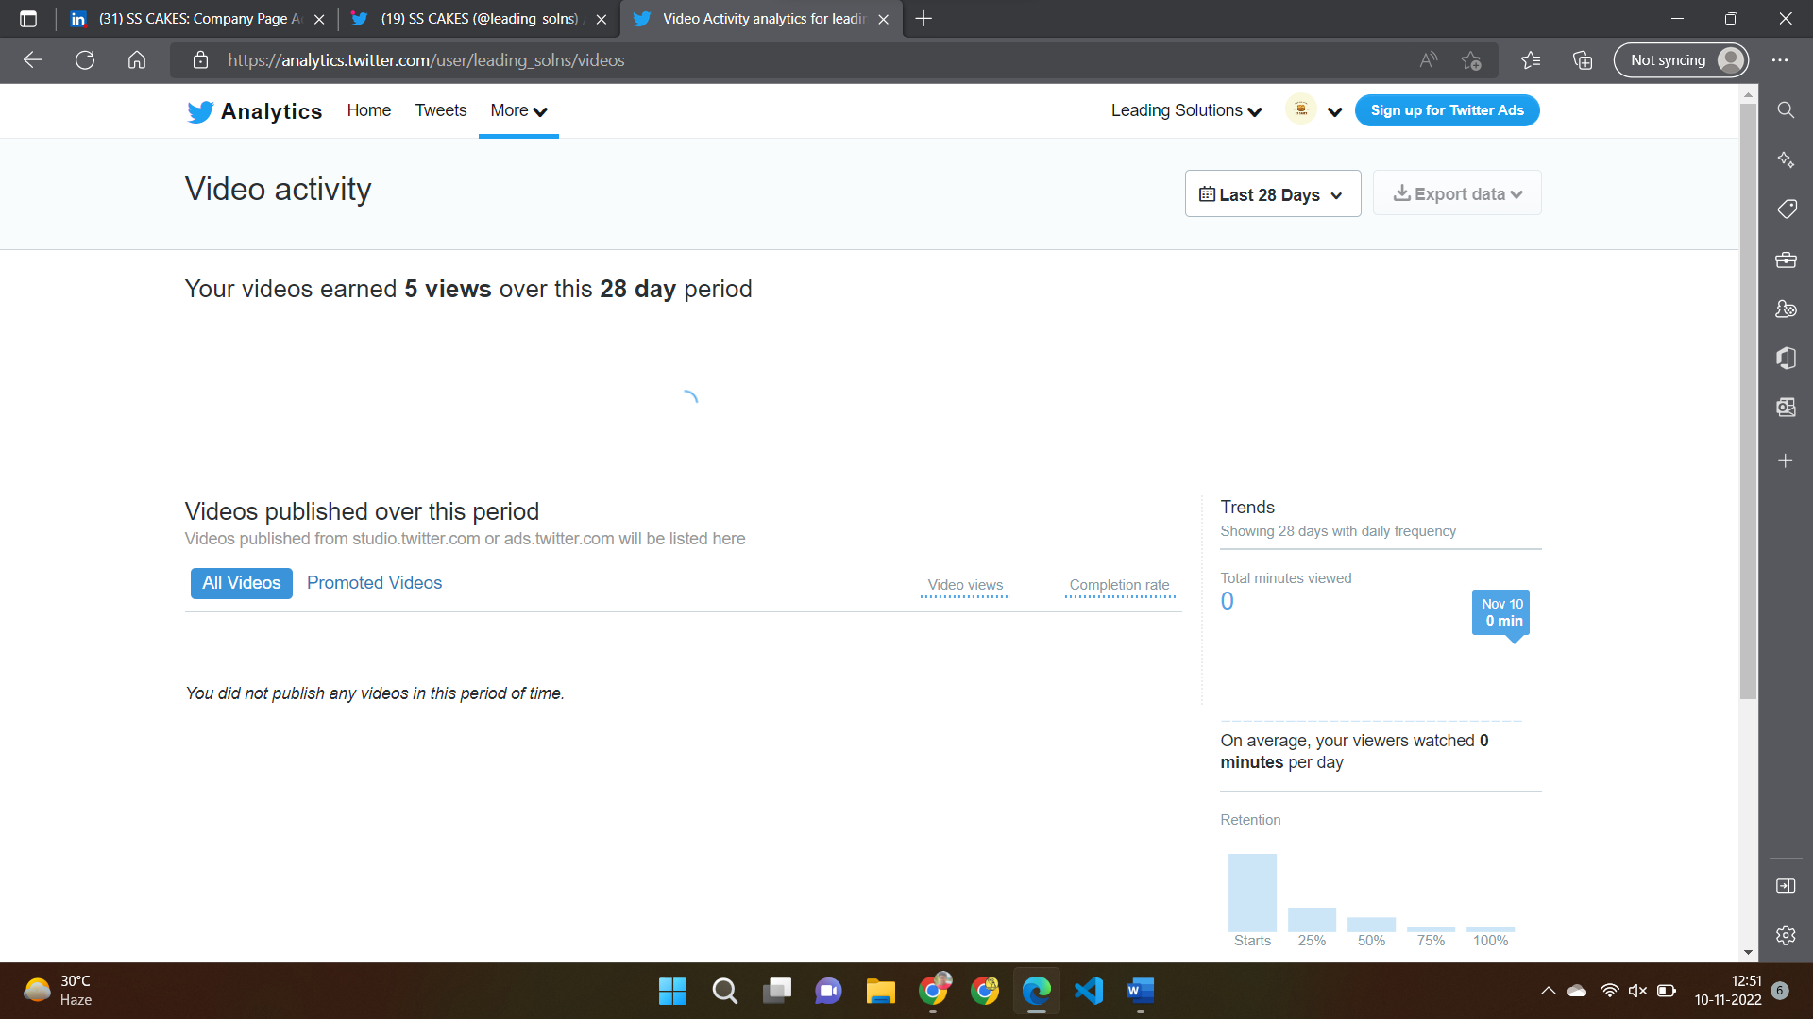

Professional TOOLs -> Professional Home

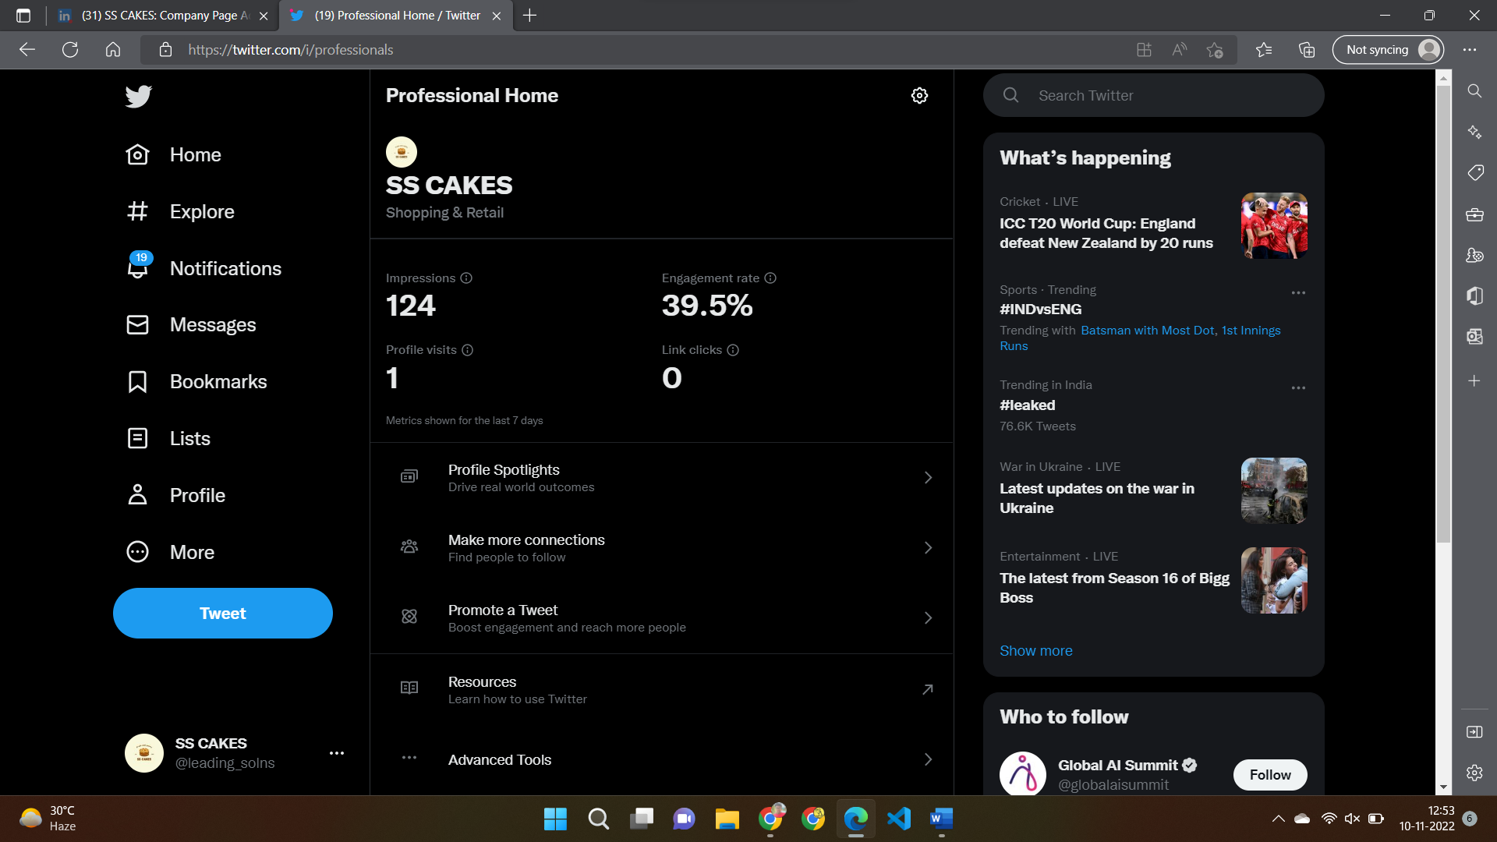

* + Page Reach has been extremely good for the past 2 weeks, that is , since the account creation and the graph shows a growth in followers and impressions metrics.
  + Regular tweets would increase the page reach more and eventually increasing the link clicks.
  + Tweets with engaging content would boost the page and tweet growth .

# OVERALL:

Website link: <https://santhoshkv0578.wixsite.com/my-site/shop>

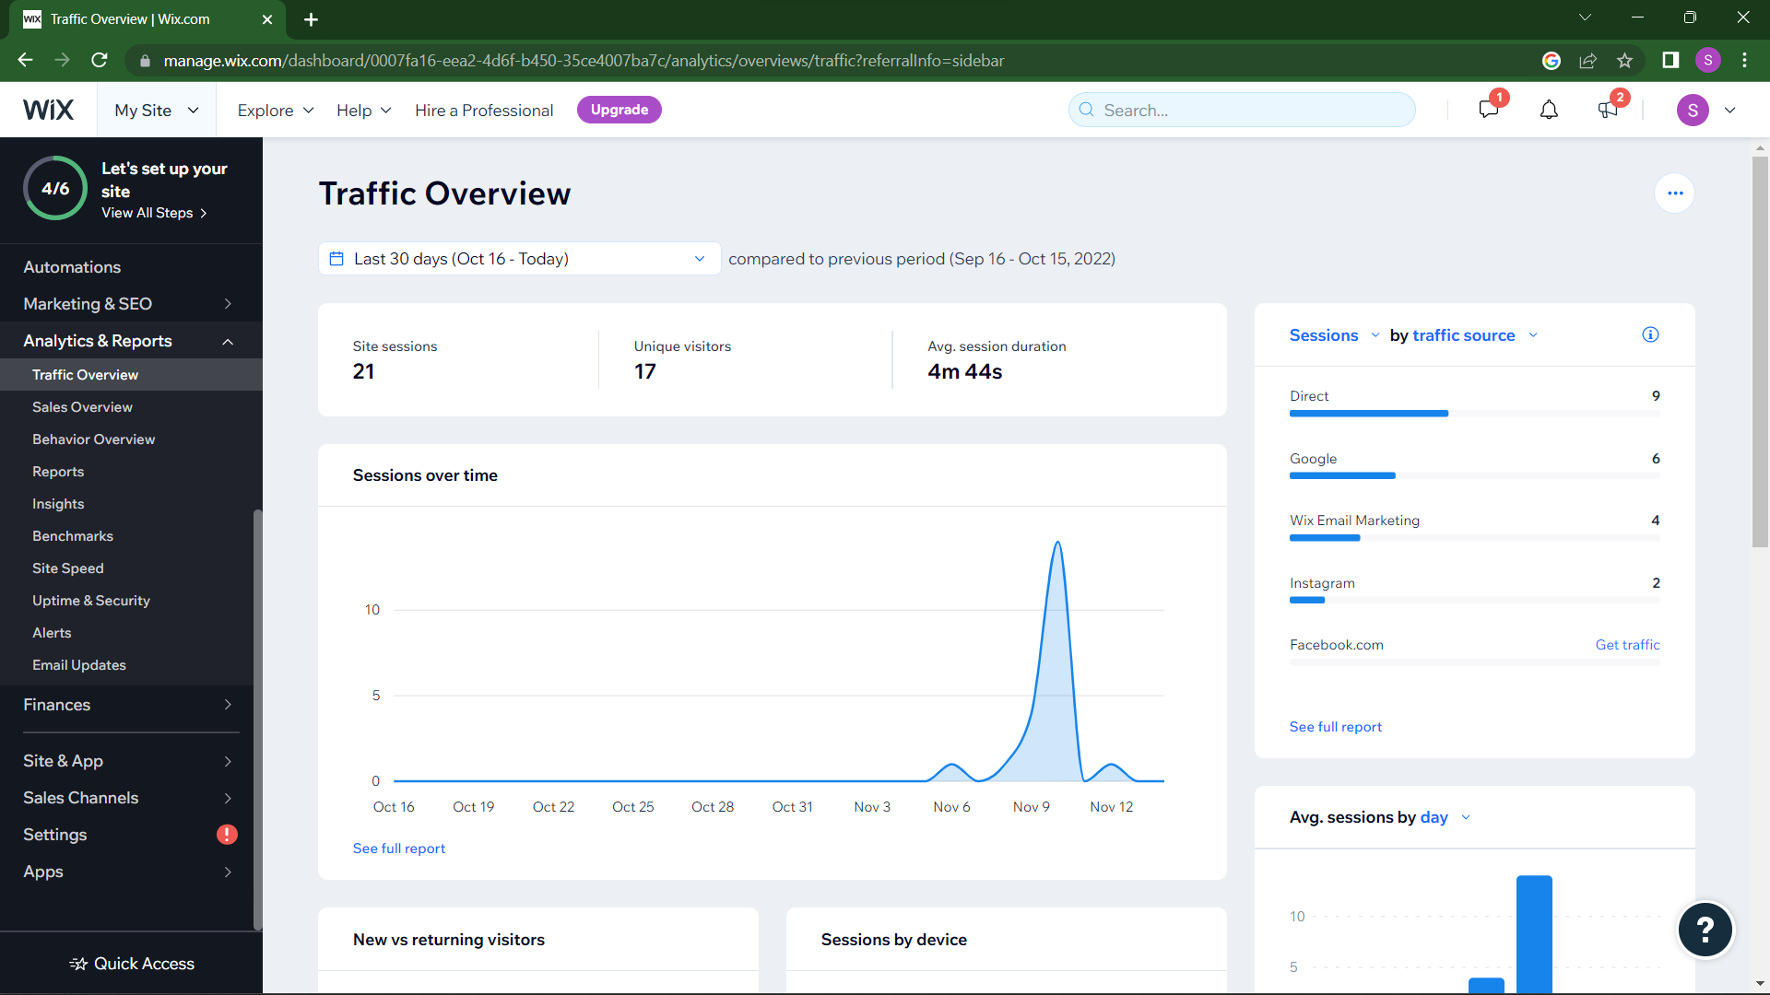

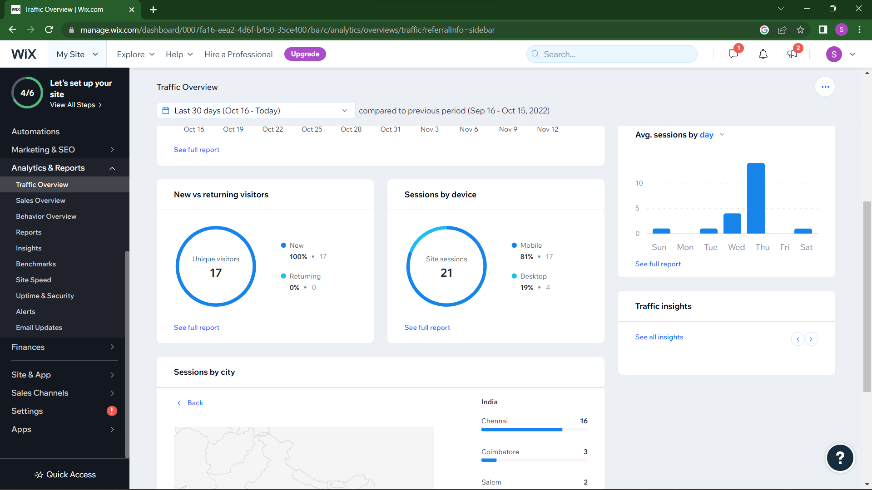

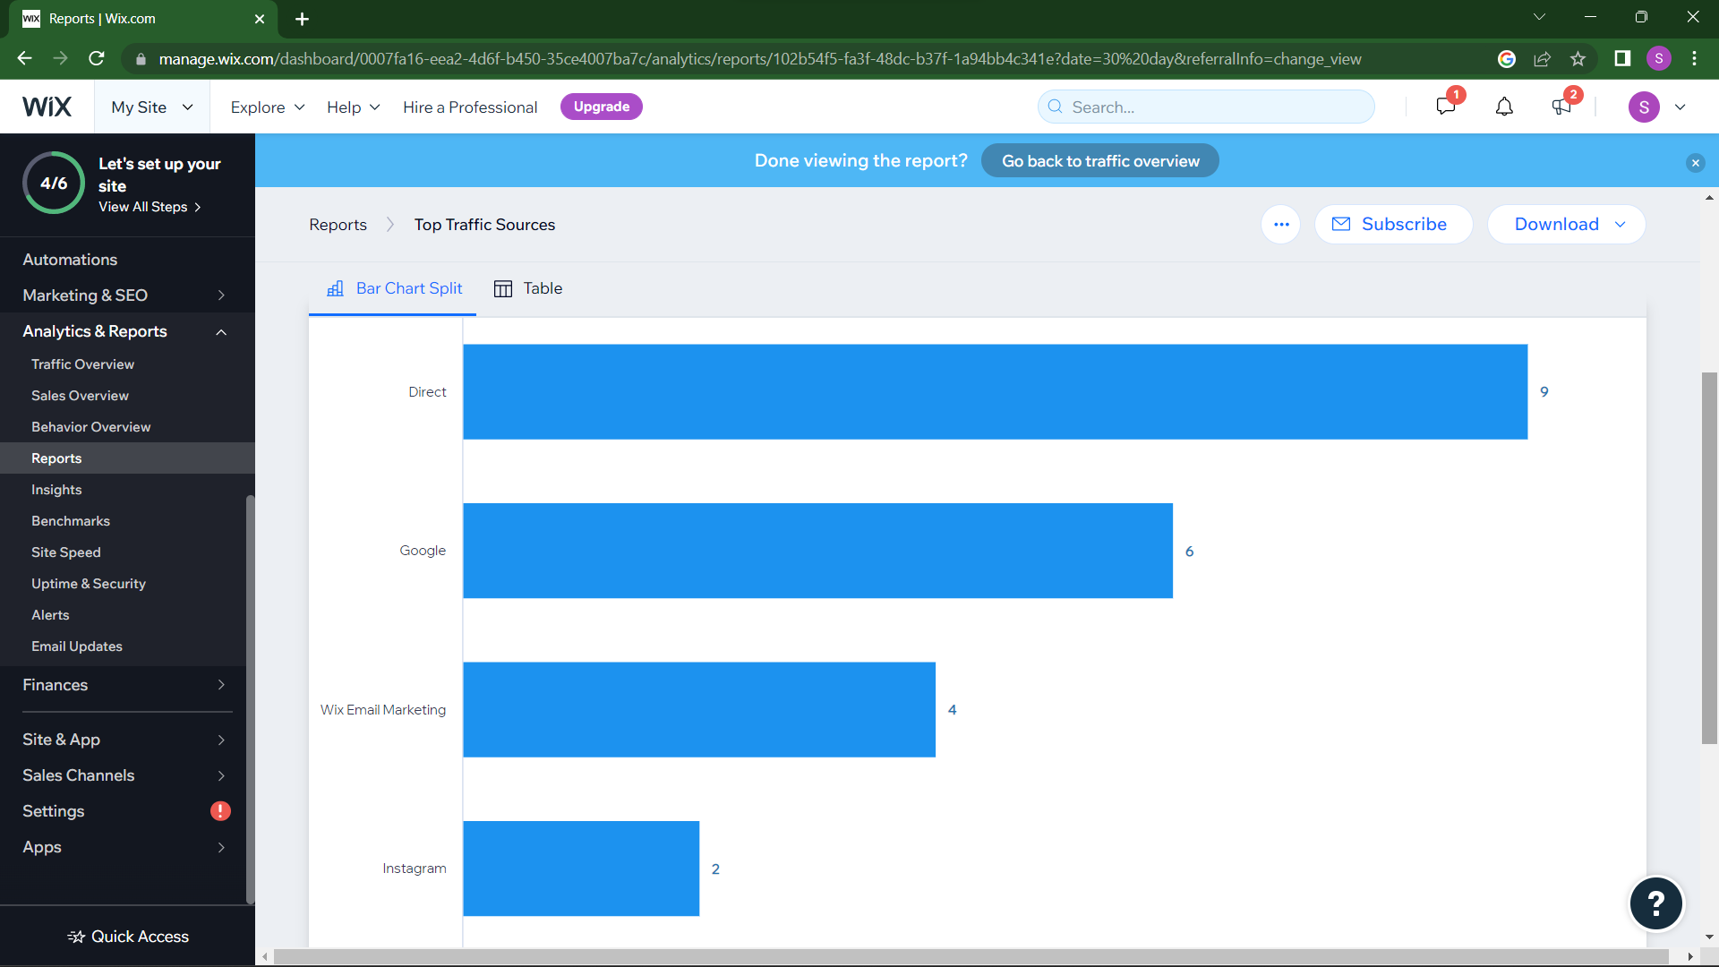

* + From the above graphs and reports, it is evident that YouTube has driven more visitors than the other social media channels and LinkedIn and Instagram being the least.
  + Facebook and twitter also shows poor traffic medium and mail marketing also has a very less impact on overall visits of the site.
  + The average duration of the visitor is also less suggesting that the website has to be more engaging and must be revaluated to increase sales and revenue.
  + Overall site sessions are also less , suggesting more concentration on marketing.
  + 60% of the site session has been through social media links from which we have to consider improving our SEO and also must improve brand awareness.
  + Neverthless , the visitors has been increasing consistently, from which it can be said that the marketing has increased and increasing the traffic effectively and must be boosted up so that the business gets more desired results or outcomes.

# CONCLUSION:

Digital marketing is vital for every business scenario as promoting through papers, televisions and radio does not have that much reach as compared to this new method. This project has helped the team to learn how to sell our product to target customers easily and efficiently.

In a overall view, this project has been a success as the traffic of our website is slowly increasing. Twitter and Youtube has shown the most reach as compared to other social media platforms and has therefore led more traffic to our website more. The website is connected to WIXAnalytics which shows the insights about the website. The main goal was to promote the website, for which social media platforms was a great medium .

In future, the business needs to maintain its social media presence and try out inorganic methods to boost results first and then go on to organic ways as the business first needs brand awareness which would be difficult in the case of organic methods.Also, devising an improved digital marketing plan with better tools must be incorporated to enhance traffic and sales of the business.

#### ***********